

Wheat rust advisory - risk assessment from surveys and forecasts in Bhutan

Summary period: 30 Jan - 05 Feb 2024

Overall risk level:
Caution / Low

Key messages
The first incidence of stripe rust is being reported from research stations in Pakistan and Nepal. Conditions across the region have been generally cold and dry with no winter rainfall.
During the period 31 Jan – 8 Feb, some rain is forecast across Bhutan and this is forecast to continue during 8 – 16 Feb. Temperatures are likely to remain cooler than average.
These weather conditions are likely to be favorable for the development of rusts, especially stripe rust.
Conducive conditions for rust infection are forecast (30 Jan – 4 Feb) in southern areas and the mid hill areas (stripe rust).

Recommendations
Suitable conditions for stripe rust are likely to develop due to forecast rain over the next 1-2 weeks. Scouting should be undertaken and farmers informed to be vigilant for the emergence of stripe rust. If stripe rust starts to appear farmers should be advised to undertake control if susceptible cultivars are grown.
- Awareness should be raised amongst stakeholders at all levels, including farmers, to be vigilant for early appearance of rusts. Early control to stop increased spread and further build-up of disease is very important.
- Sampling should be undertaken to determine races of rust present.

Field surveys
No surveys are available in this region yet.

Spore dispersal forecasts
Spore dispersal forecasts run by the UK Met Office and Cambridge University are displayed for stem, stripe and leaf rusts for the forecasted period. Surveys in each district are gathered to provide a single source per administrative area for dispersal forecasts (red dots in figure).

Environmental / climatic suitability for infection forecasts
These forecasts give the probability of wheat rust infection occurring based on meteorological factors. The maximum infection efficiency that can occur is 100%. This means that 100% of the spores deposited on susceptible wheat plants could complete the infection process. Therefore, a forecast Infection Efficiency of 100% indicates the highest risk of wheat rust infection occurring in susceptible wheat varieties.

Leaf rust
Current forecast (30 Jan - 05 Feb) indicates no dispersal as no reports of leaf rust.
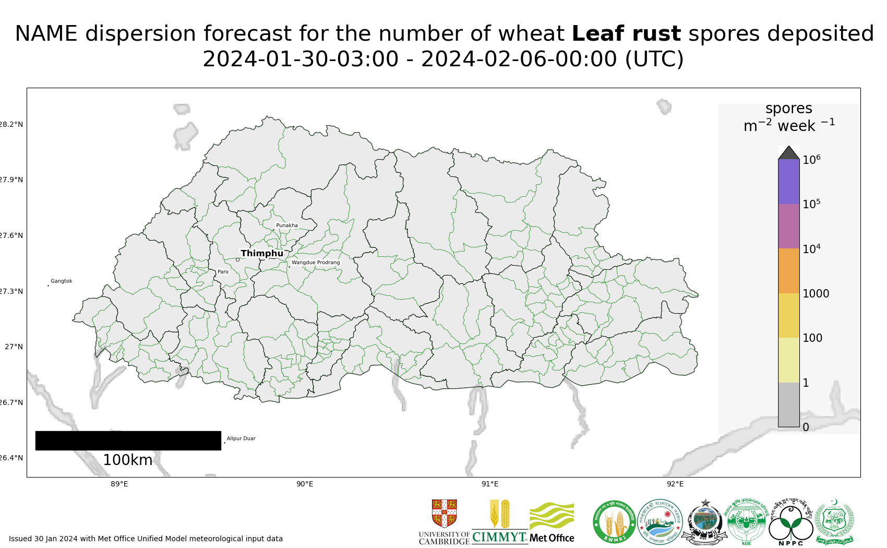
Map 1: Leaf rust spore deposition forecast Bhutan 30 Jan - 05 Feb 2024
Risk of infection: Current forecast (30 Jan – 4 Feb) indicates high infection efficiency in lowland southern areas and some moderate infection efficiency in the lower mid hills.
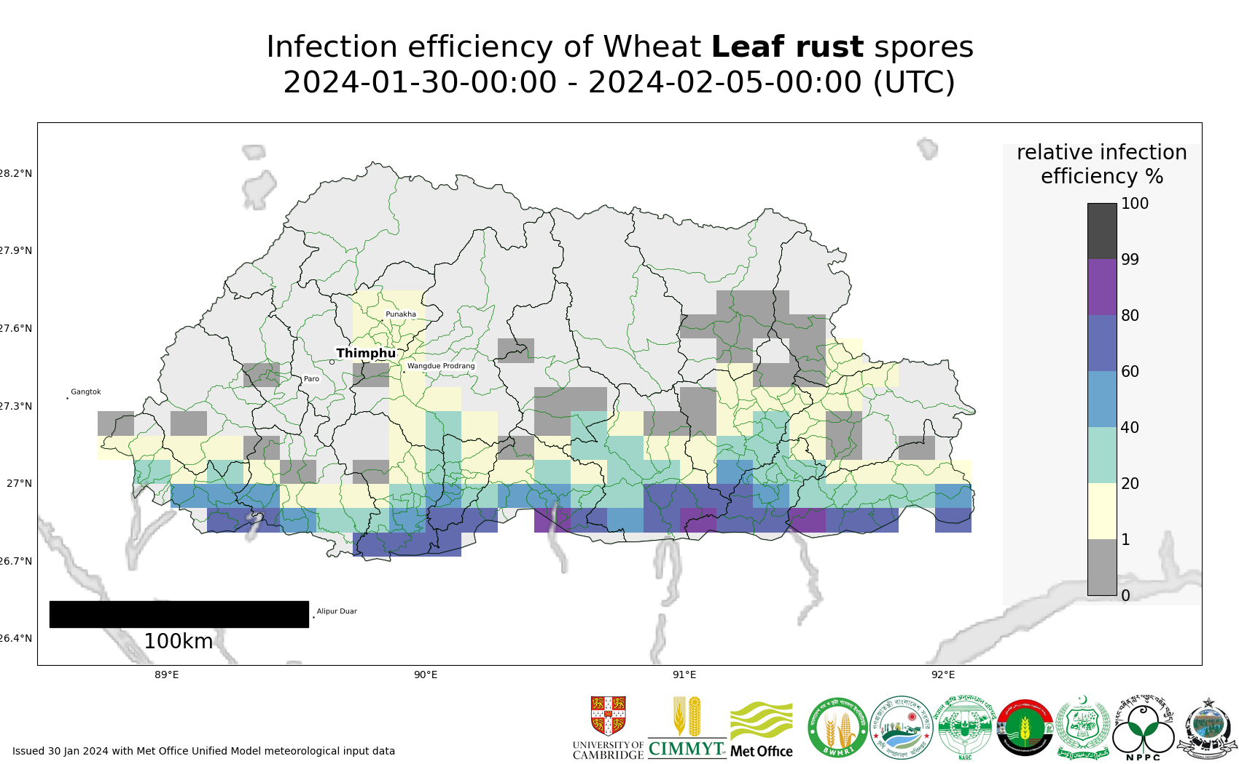
Map 2: Leaf rust suitability for infection forecast Bhutan 30 Jan - 04 Feb 2024

Stripe rust
Dispersal: Current forecast (30 Jan - 05 Feb) indicates dispersal and some low density spore deposition in an easterly direction form the reported infected site in Nepal.
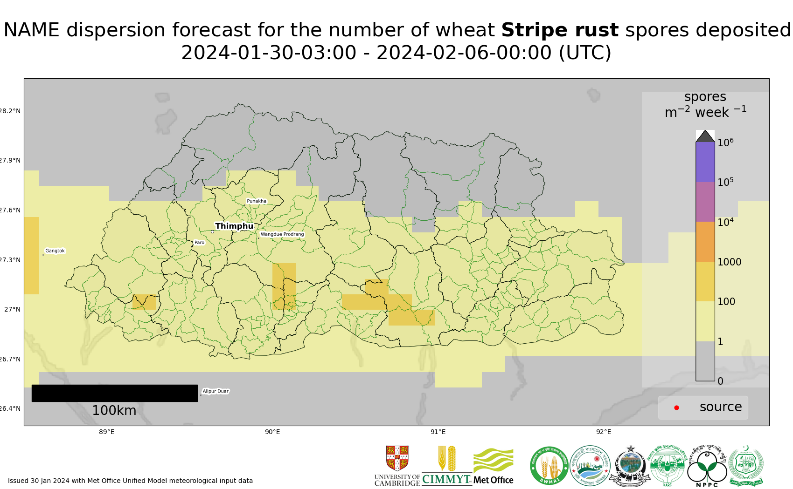
Map 3: Stripe rust spore deposition forecast Bhutan 30 Jan - 05 Feb 2024
Risk of infection: Current forecast (30 Jan – 4 Feb) indicates high infection efficiency in lowland southern areas and in the lower mid hills.
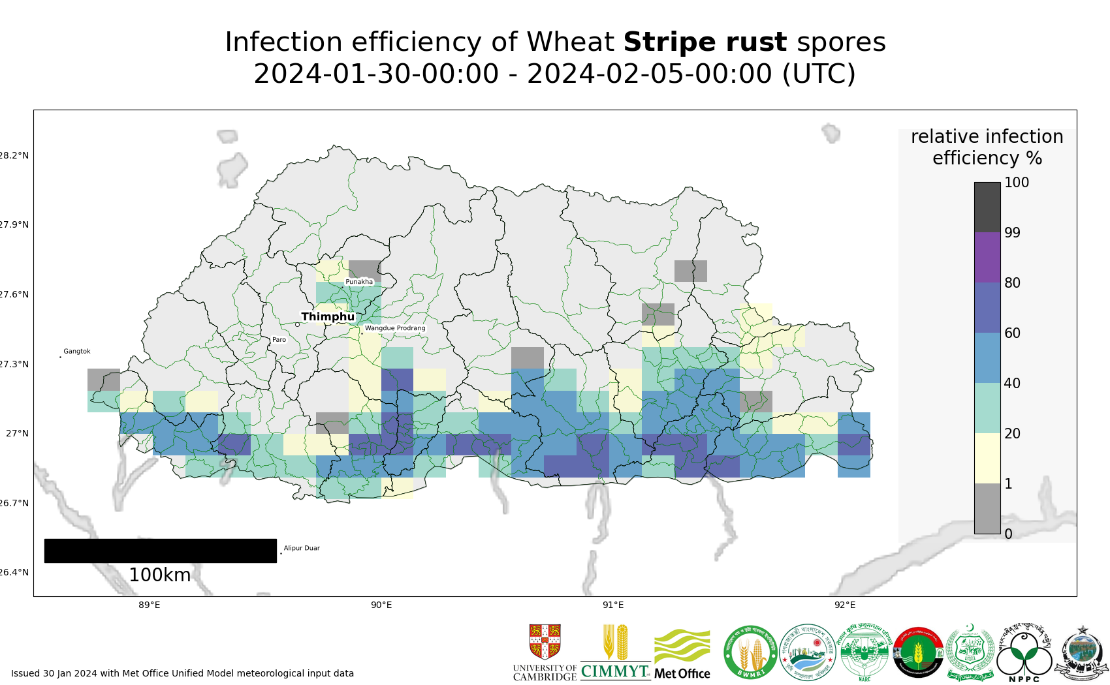
Map 4: Stripe rust suitability for infection forecast Bhutan 30 Jan - 04 Feb 2024

Stem rust
Dispersal: Current forecast (30 Jan - 05 Feb) indicates no dispersal as no reports of stem rust.
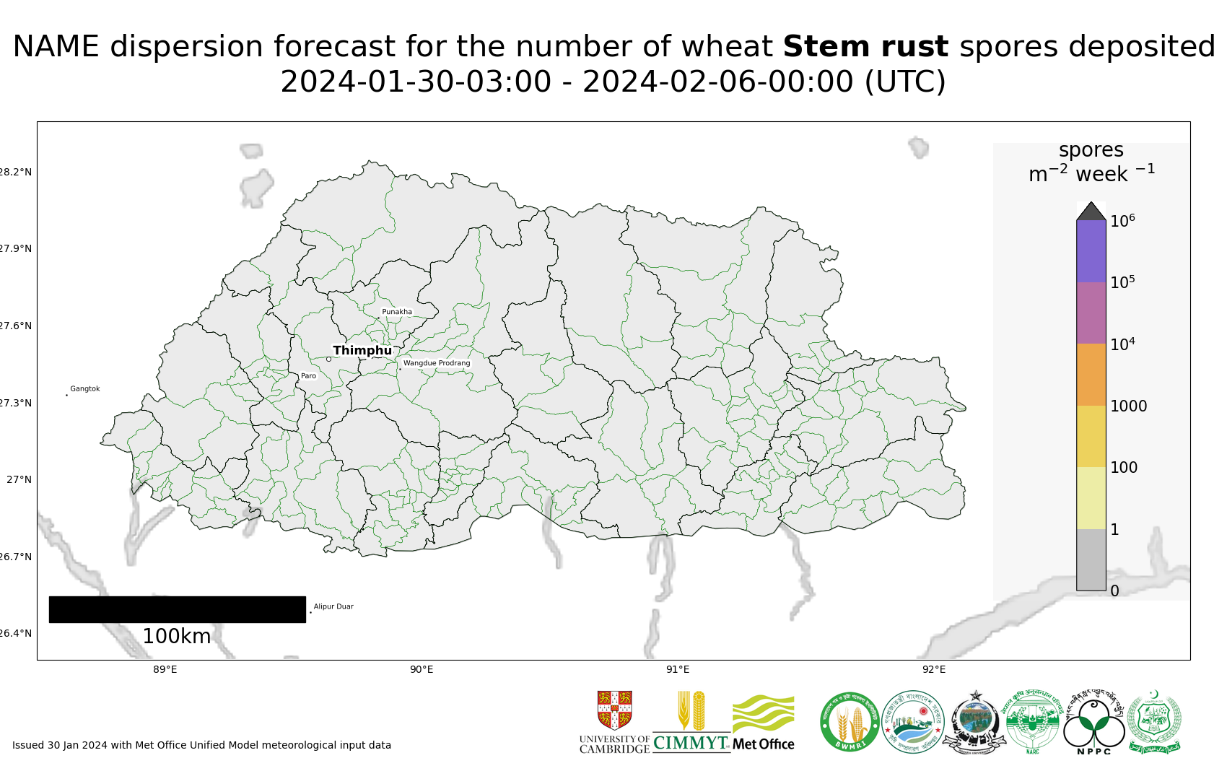
Map 5: Stem rust spore deposition forecast Bhutan 30 Jan - 05 Feb 2024
Risk of infection: Current forecast (30 Jan – 4 Feb) indicates high infection efficiency in lowland southern areas and some moderate infection efficiency in the lower mid hills.
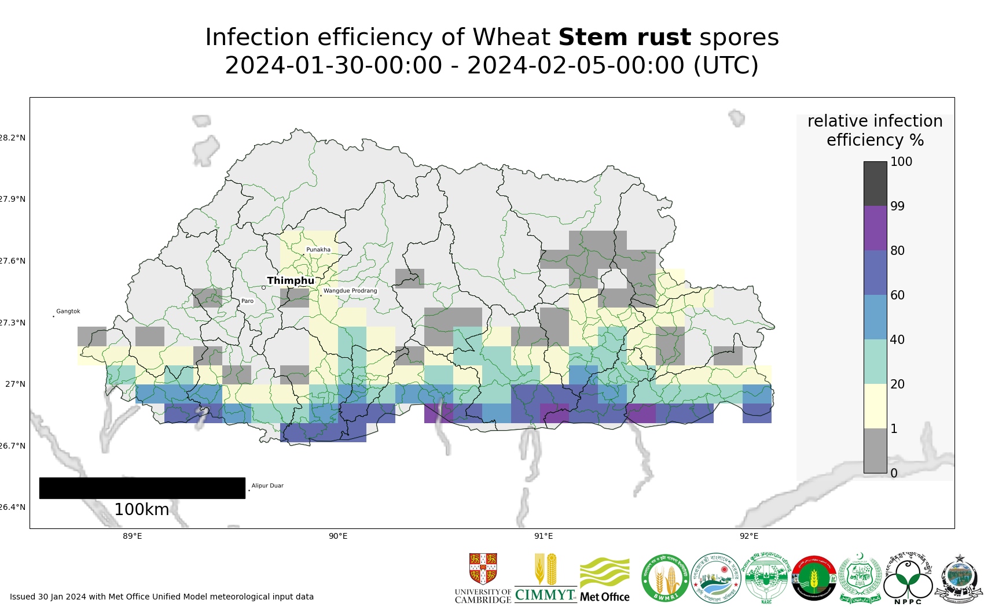
Map 6: Stem rust suitability for infection forecast Bhutan 30 Jan - 04 Feb 2024

Regional Forecasts – Precipitation & Temperature
Forecasts from the National Centers for Environmental Prediction (NCEP)[ http://wxmaps.org/pix/clim]
These indicate possible general conditions across South Asia, with likely decreasing prediction accuracy in the second forecast period.
During the period 31 Jan – 8 Feb, some rain is forecast for northern and southern Pakistan, north-west India and the mid/ higher hill areas of Nepal and across Bhutan. Lighter rain is also forecast for Bangladesh. During the period 8 – 16 Feb, little or no rain is forecast for Nepal, but rain will continue in Bhutan.
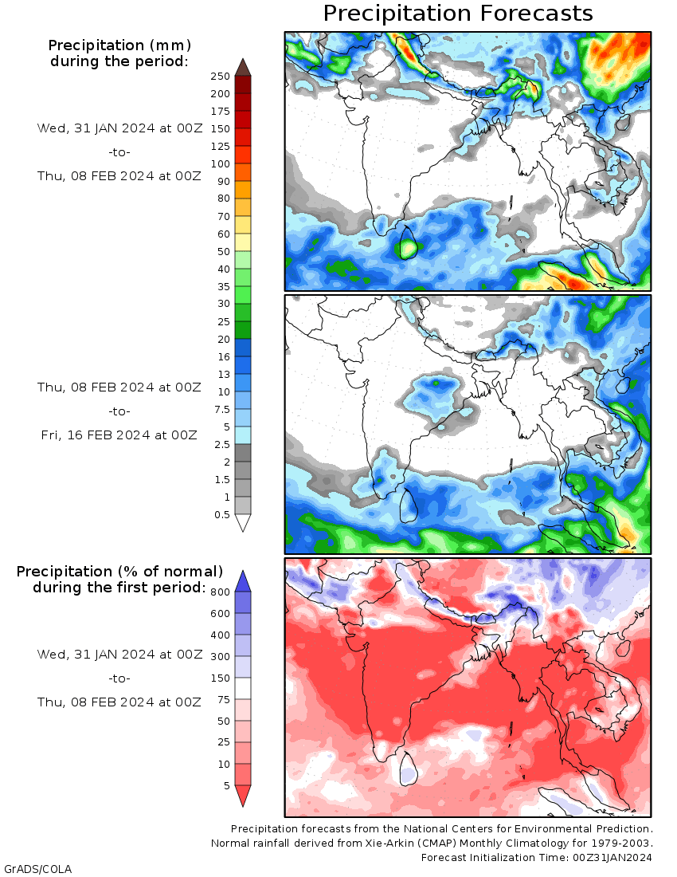
Temperature: During the period 31 Jan – 8 Feb, cool temperatures will prevail in northern and western Pakistan, parts of northern India, the higher hills of Nepal and across Bhutan. Warmer temperatures will prevail in other areas, including the eastern lowlands of Nepal and Bangladesh. A similar pattern of temperatures is forecast during the period 8-16 Feb.

