

Wheat rust advisory - risk assessment from surveys and forecasts in Bhutan

Summary period: 11 Feb - 17 Feb 2024

Overall risk level:
Caution / Low

Key messages
Current situation is calm. Current dry conditions indicate low risk for rust infections. However, during the period 13 - 21Feb, light rain is forecast for Bhutan, and during the period 21 – 29 Feb, further heavier rain is forecast across Bhutan. Temperatures are warming across the region, but likely to remain cool in Bhutan.
These weather conditions are likely to be favorable for the development of rusts, especially stripe rust.

Recommendations
Suitable conditions for stripe rust are likely to develop due to forecast rain over the next 1-2 weeks. Scouting should be undertaken and farmers informed to be vigilant for the emergence of stripe rust. If stripe rust starts to appear farmers should be advised to undertake control if susceptible cultivars are grown.
- Awareness should be raised amongst stakeholders at all levels, including farmers, to be vigilant for early appearance of rusts. Early control to stop increased spread and further build-up of disease is very important.
- Sampling should be undertaken to determine races of rust present.

Field surveys
No surveys are available in this region yet.

Spore dispersal forecasts
Spore dispersal forecasts run by the UK Met Office and Cambridge University are displayed for stem, stripe and leaf rusts for the forecasted period. Surveys in each district are gathered to provide a single source per administrative area for dispersal forecasts (red dots in figure).

Environmental / climatic suitability for infection forecasts
These forecasts give the probability of wheat rust infection occurring based on meteorological factors. The maximum infection efficiency that can occur is 100%. This means that 100% of the spores deposited on susceptible wheat plants could complete the infection process. Therefore, a forecast Infection Efficiency of 100% indicates the highest risk of wheat rust infection occurring in susceptible wheat varieties.

Leaf rust
Dispersal: Current forecast (11 Feb - 17 Feb) indicates no dispersal / deposition as no observations reported.
Risk of infection: Current forecast (11 – 16 Feb) indicates generally low infection efficiency, with some pockets of moderate infection efficiency in lowland southern areas.
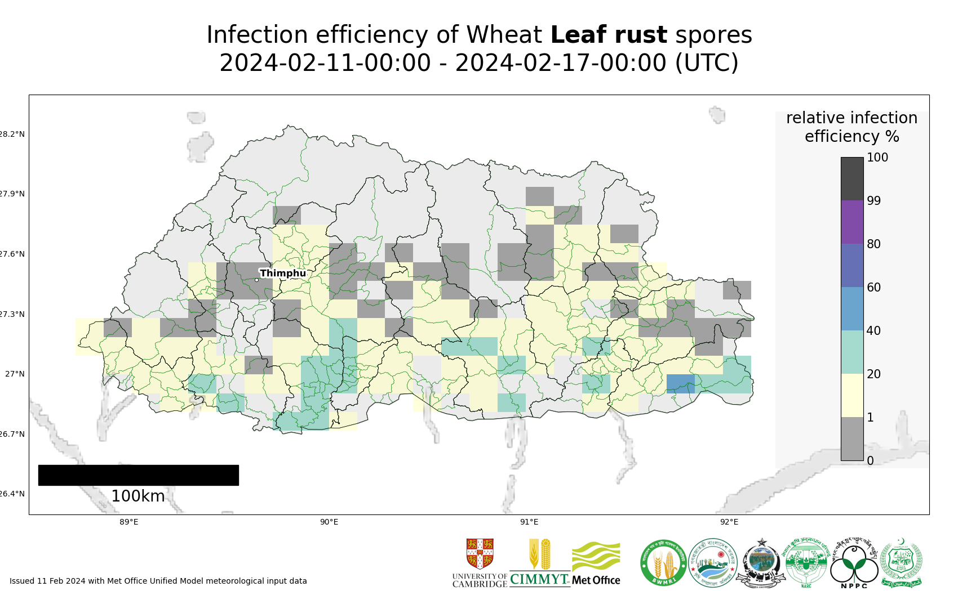
Map 2: Leaf rust suitability for infection forecast Bhutan 11 Feb - 16 Feb 2024
The 20 most impacted districts (infection efficiency) are presented in the table below.
admin2Name | RIE_leaf_rust_%
Gozhi | 31
Samrang | 28
Pemathang | 25
Serthig | 25
Drugyelgang | 24
Gesarling | 23
Phuntsthothang | 22
Tsholingkhor | 22
Tsangkha | 22
Tsendagang | 21
Samphelling | 21
Rangthangling | 20
Deorali | 20
Lajab | 20
Khipisa | 20
Dorona | 20
Trashiding | 20
Barzhong | 20
Gozhing | 20
Logchina | 19

Stripe rust
Dispersal: Current forecast (11 Feb - 17 Feb) indicates some very low density spore deposition from infected sites in Nepal in the western part of Bhutan.
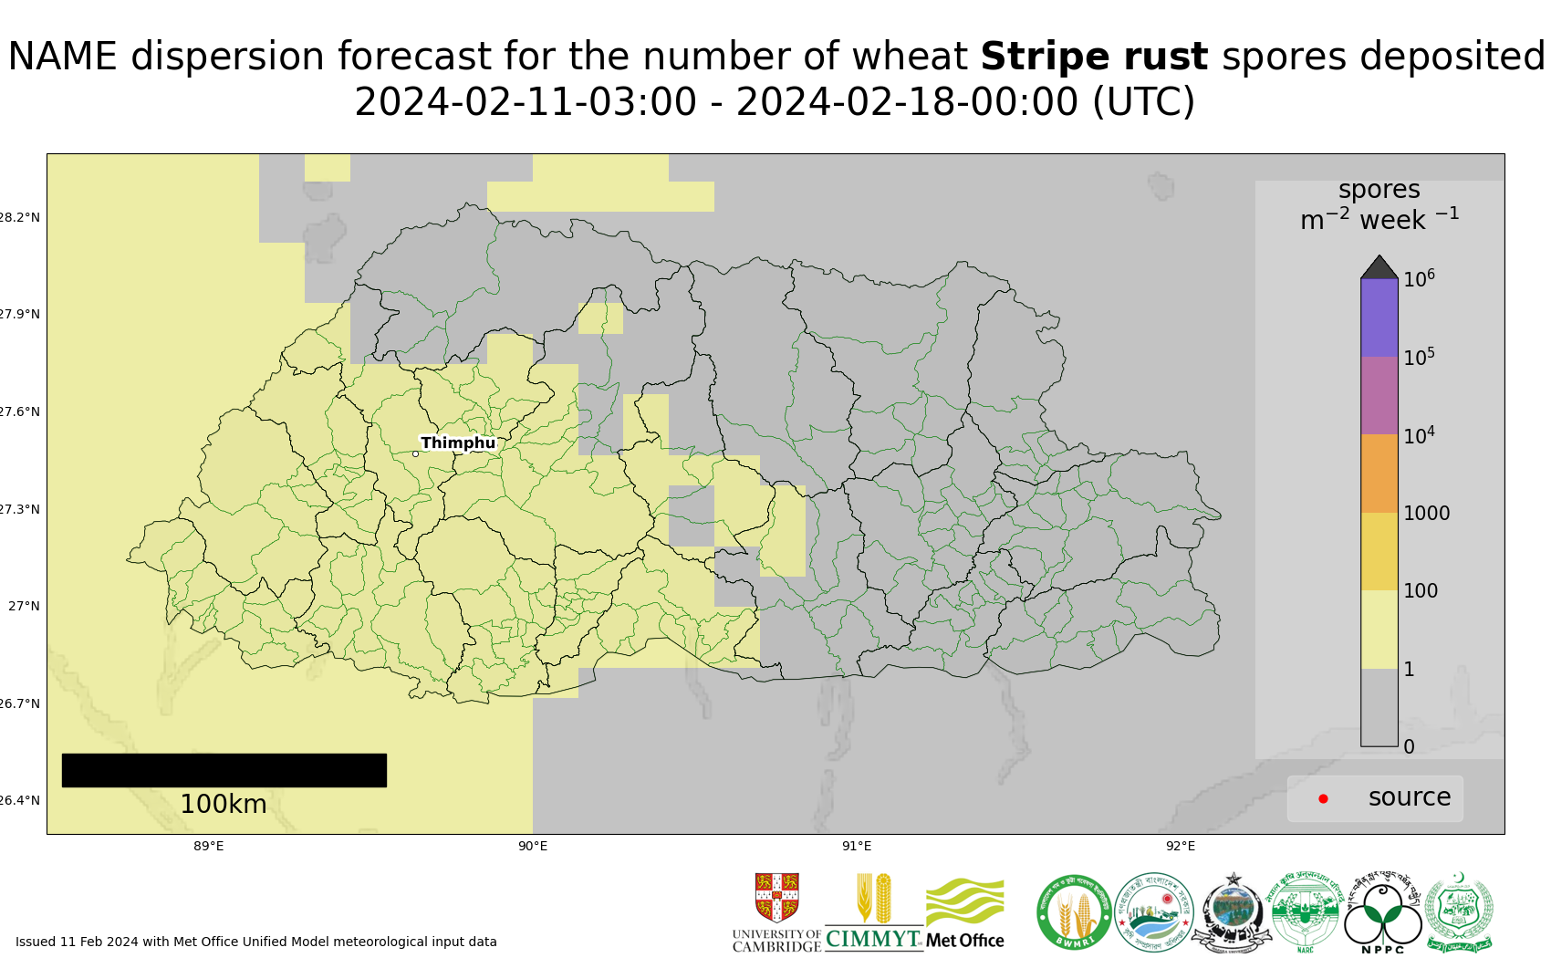
Map 3: Stripe rust spore deposition forecast Bhutan 11 Feb - 17 Feb 2024
The 20 most impacted districts (spore deposition) are presented in the table below.
admin2Name | Stripe rust spores per m^2 per week
Bara | 7
Daga | 7
Chapchha | 7
Tendu | 6
Metap | 6
Genye | 6
Doga | 6
Sipsu | 6
Dagala | 6
Naja | 6
Bjachho | 6
Dungna | 5
Sombey | 5
Geling | 5
Biru | 5
Ruepisa | 5
Patakla | 5
Tseza | 5
Gakiling | 4
Namgyel Chhoeling | 4

Risk of infection: Current forecast (11 – 16 Feb) indicates generally low infection efficiency, with some very small pockets of moderate infection efficiency.
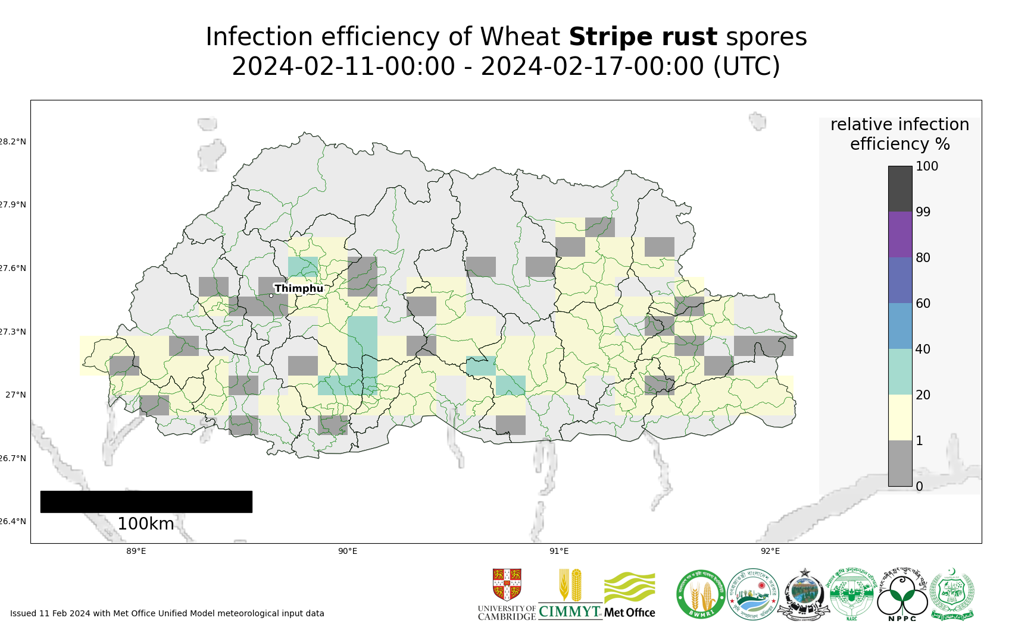
Map 4: Stripe rust suitability for infection forecast Bhutan 11 Feb - 16 Feb 2024
The 20 most impacted districts (infection efficiency) are presented in the table below.
admin2Name | RIE_stripe_rust_%
Lajab | 25
Tsholingkhor | 23
Tsangkha | 23
Patakla | 21
Drugyelgang | 20
Shemjong | 18
Gosarling | 18
Chhubu | 18
Tsirangtoe | 18
Daga | 17
Rangthangling | 16
Talo | 15
Barzhong | 15
Khipisa | 15
Phangyuel | 14
Lingmukha | 14
Kikorthang | 14
Dzoma | 14
Trong | 14
Kalidzingkha | 14

Stem rust
Current forecast (11 Feb - 17 Feb) indicates no dispersal as no reports of stem rust.
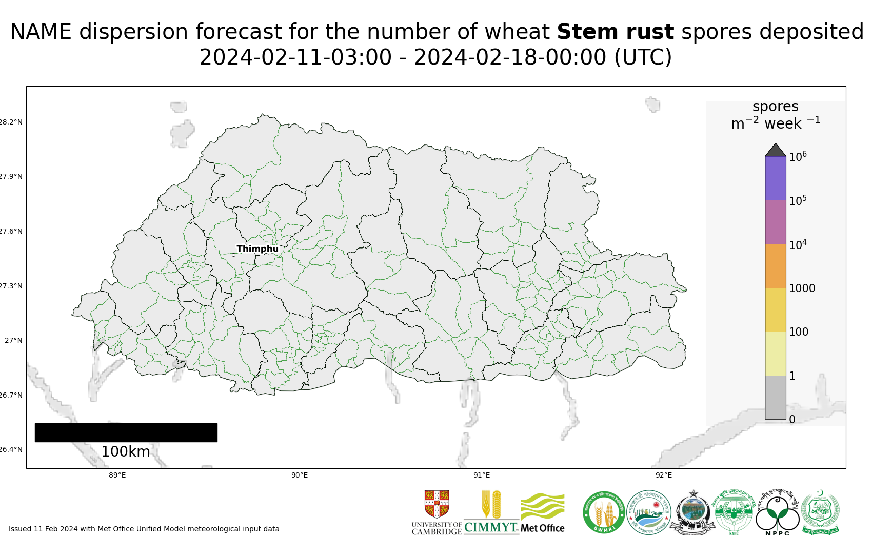
Map 5: Stem rust spore deposition forecast Bhutan 11 Feb - 17 Feb 2024
Risk of infection: Current forecast (11 – 16 Feb) indicates generally low infection efficiency, with some pockets of moderate infection efficiency in lowland southern areas.
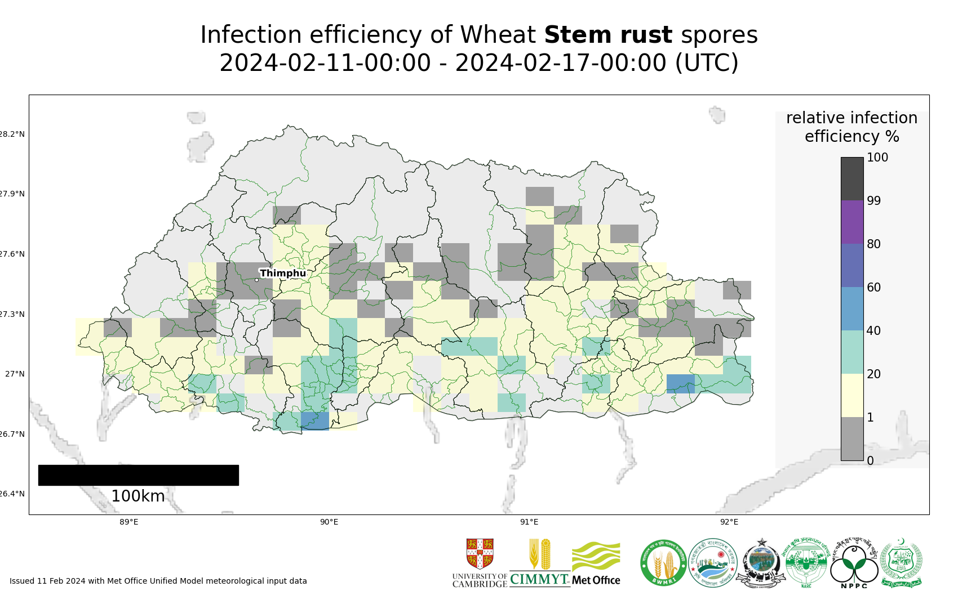
Map 6: Stem rust suitability for infection forecast Bhutan 11 Feb - 16 Feb 2024
The 20 most impacted districts (infection efficiency) are presented in the table below.
admin2Name | RIE_stem_rust_%
Gozhi | 31
Deorali | 29
Lhamoizingkha | 28
Tsendagang | 28
Samrang | 28
Nichula | 27
Tading | 25
Dorona | 25
Samphelling | 25
Serthig | 25
Pemathang | 25
Drugyelgang | 24
Gesarling | 23
Tsholingkhor | 22
Tsangkha | 22
Phuntsthothang | 22
Gozhing | 22
Phuentsholing | 21
Barzhong | 20
Rangthangling | 20

Regional Forecasts – Precipitation & Temperature
Forecasts from the National Centers for Environmental Prediction (NCEP)[ http://wxmaps.org/pix/clim]
These indicate possible general conditions across South Asia, with likely decreasing prediction accuracy in the second forecast period.
During the period 13 - 21Feb, rain is forecast for northern Pakistan, north-west India and the hill areas of Nepal and Bhutan. Some light rain is also forecast for west central Bangladesh. During the period 21 – 29 Feb, further rain is forecast – light in northern Pakistan, but heavier in north west India, across Nepal, Bhutan and for most of Bangladesh.
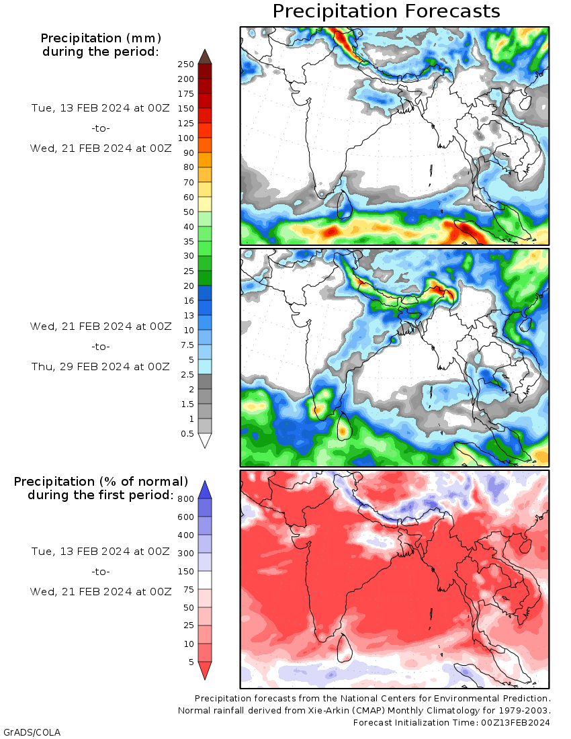
Temperature: During the period 13 - 21 Feb, warmer temperatures are starting prevail across most of the region, except for the west and far north of Pakistan, and across Bhutan. Warmer temperatures will prevail in other areas, including Bangladesh. A similar pattern of temperatures is forecast during the period 21 -29 Feb.

