

Wheat rust advisory - risk assessment from surveys and forecasts in Bhutan

Summary period: 22 Feb - 28 Feb 2024

Overall risk level:
Caution / Low

Key messages
Current situation is calm. Current model forecasts indicate low risk for rust infections. However, during the period 22 Feb – 1Mar, moderate rain is forecast for Bhutan and light rain continuing during 1 – 9 Mar. Temperatures are forecast to be relatively cool for 22 Feb – 1Mar.

These weather conditions are likely to be favorable for the development of rusts, especially stripe rust.

Recommendations
Suitable conditions for stripe rust are likely to develop due to forecast rain over the next 1-2 weeks. Scouting should be undertaken and farmers informed to be vigilant for the emergence of stripe rust. If stripe rust starts to appear farmers should be advised to undertake control if susceptible cultivars are grown.
- Awareness should be raised amongst stakeholders at all levels, including farmers, to be vigilant for early appearance of rusts. Early control to stop increased spread and further build-up of disease is very important.
- Sampling should be undertaken to determine races of rust present.

Field surveys
No surveys are available in this region yet.

Spore dispersal forecasts
Spore dispersal forecasts run by the UK Met Office and Cambridge University are displayed for stem, stripe and leaf rusts for the forecasted period. Surveys in each district are gathered to provide a single source per administrative area for dispersal forecasts (red dots in figure).

Environmental / climatic suitability for infection forecasts
These forecasts give the probability of wheat rust infection occurring based on meteorological factors. The maximum infection efficiency that can occur is 100%. This means that 100% of the spores deposited on susceptible wheat plants could complete the infection process. Therefore, a forecast Infection Efficiency of 100% indicates the highest risk of wheat rust infection occurring in susceptible wheat varieties.

Leaf rust
Dispersal: Current forecast (22 Feb - 28 Feb) indicates some low to moderate spore deposition from infected sites in Bangladesh into southern areas.
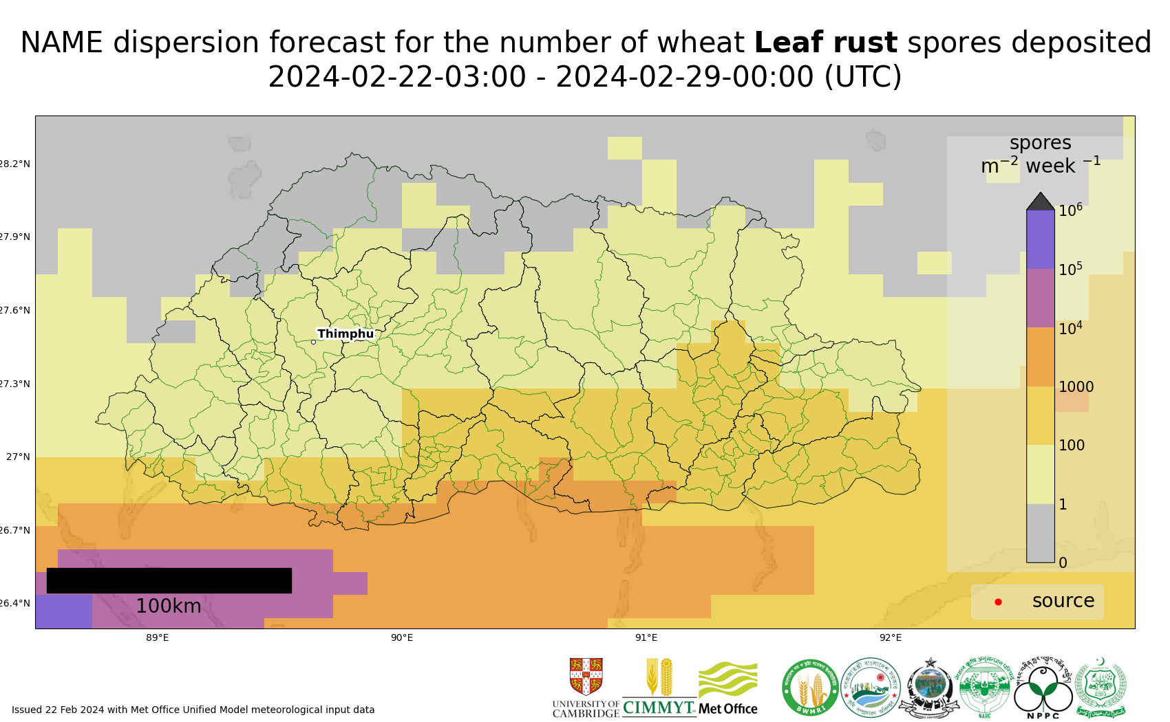
Map 1: Leaf rust spore deposition forecast Bhutan 22 Feb - 28 Feb 2024
The 20 most impacted districts (spore deposition) are presented in the table below.
admin2Name | Leaf rust spores per m^2 per week
Lhamoizingkha | 1900
Taklai | 1800
Dala | 1400
Umling | 1300
Sherzhong | 1300
Pangkhar | 1300
Senge | 1300
Shompangkha | 1200
Nichula | 1100
Gelephu | 1100
Chhuzagang | 1100
Bhur | 1000
Beteni | 960
Deorali | 930
Norbugang | 930
Dekiling | 920
Hiley | 910
Ngangla | 910
Pagli | 900
Gozhing | 900

Risk of infection: Current forecast (22 – 27 Feb) indicates generally low infection efficiency, with some small pockets of moderate infection efficiency in lowland southern areas.
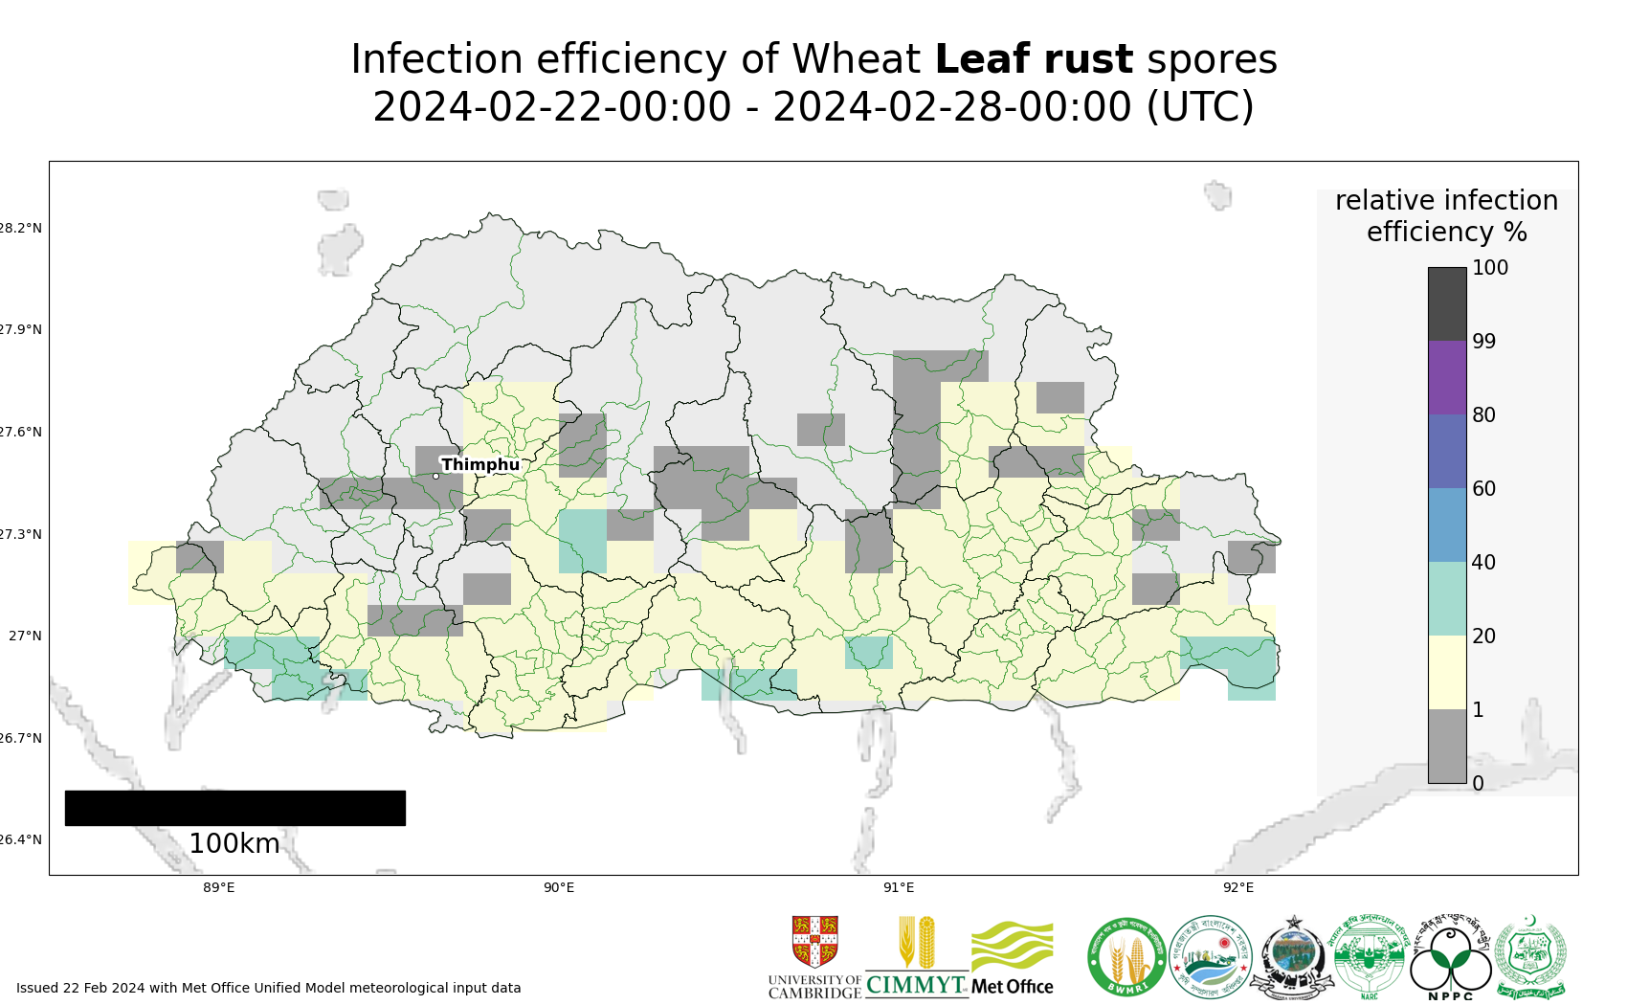
Map 2: Leaf rust suitability for infection forecast Bhutan 22 Feb - 27 Feb 2024
The 20 most impacted districts (infection efficiency) are presented in the table below. The information however should be considered along with presence of wheat, the growth stage and resistance level of the host.
admin2Name | RIE_leaf_rust_%
Pagli | 33
Samtse | 32
Ugentse | 30
Langchhenphu | 28
Umling | 27
Tading | 26
Samphelling | 25
Taklai | 24
Dorokha | 23
Sherzhong | 23
Yoeseltse | 22
Chengmari | 22
Phuentsholing | 21
Gelephu | 20
Pangkhar | 20
Gozhing | 20
Chhuzagang | 20
Samrang | 19
Dekiling | 19
Bhur | 19

Stripe rust
Dispersal: Current forecast (22 Feb - 28 Feb) indicates some low density spore deposition from infected sites in Nepal. Western areas have the highest spore deposition.
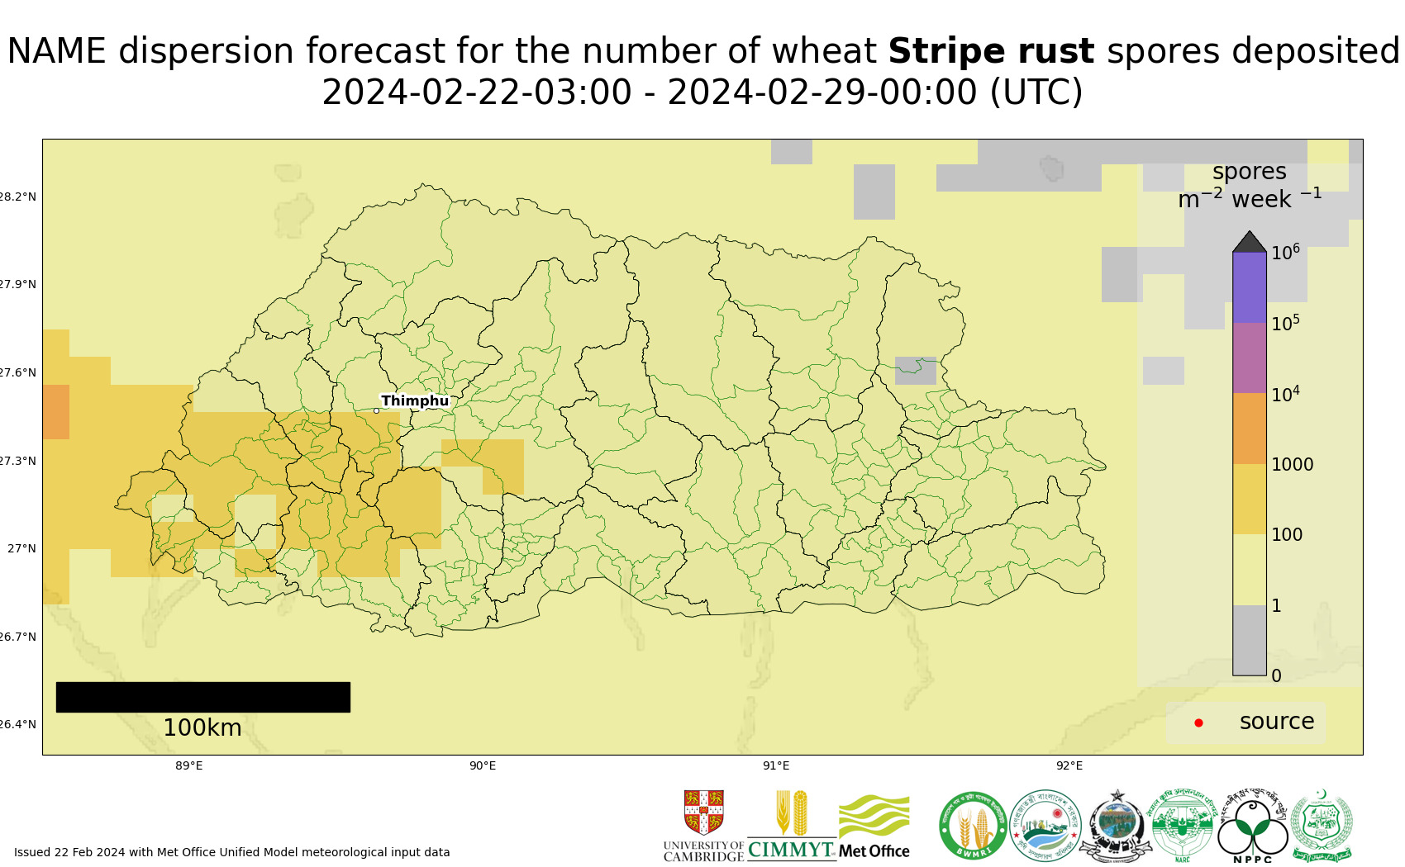
Map 3: Stripe rust spore deposition forecast Bhutan 22 Feb - 28 Feb 2024
The 20 most impacted districts (spore deposition) are presented in the table below.
admin2Name | Stripe rust spores per m^2 per week
Genye | 170
Doga | 160
Chapchha | 160
Naja | 150
Metap | 140
Bjachho | 130
Dungna | 130
Dagala | 130
Shapa | 130
Tendu | 130
Lungnyi | 130
Sombey | 130
Bara | 130
Sipsu | 120
Sama | 120
Geling | 120
Daga | 120
Uesu | 110
Namgyel Chhoeling | 110
Ruepisa | 110

Risk of infection: Current forecast (22 – 27 Feb) indicates generally low infection efficiency, with some small pockets of moderate infection efficiency in mid hill areas.
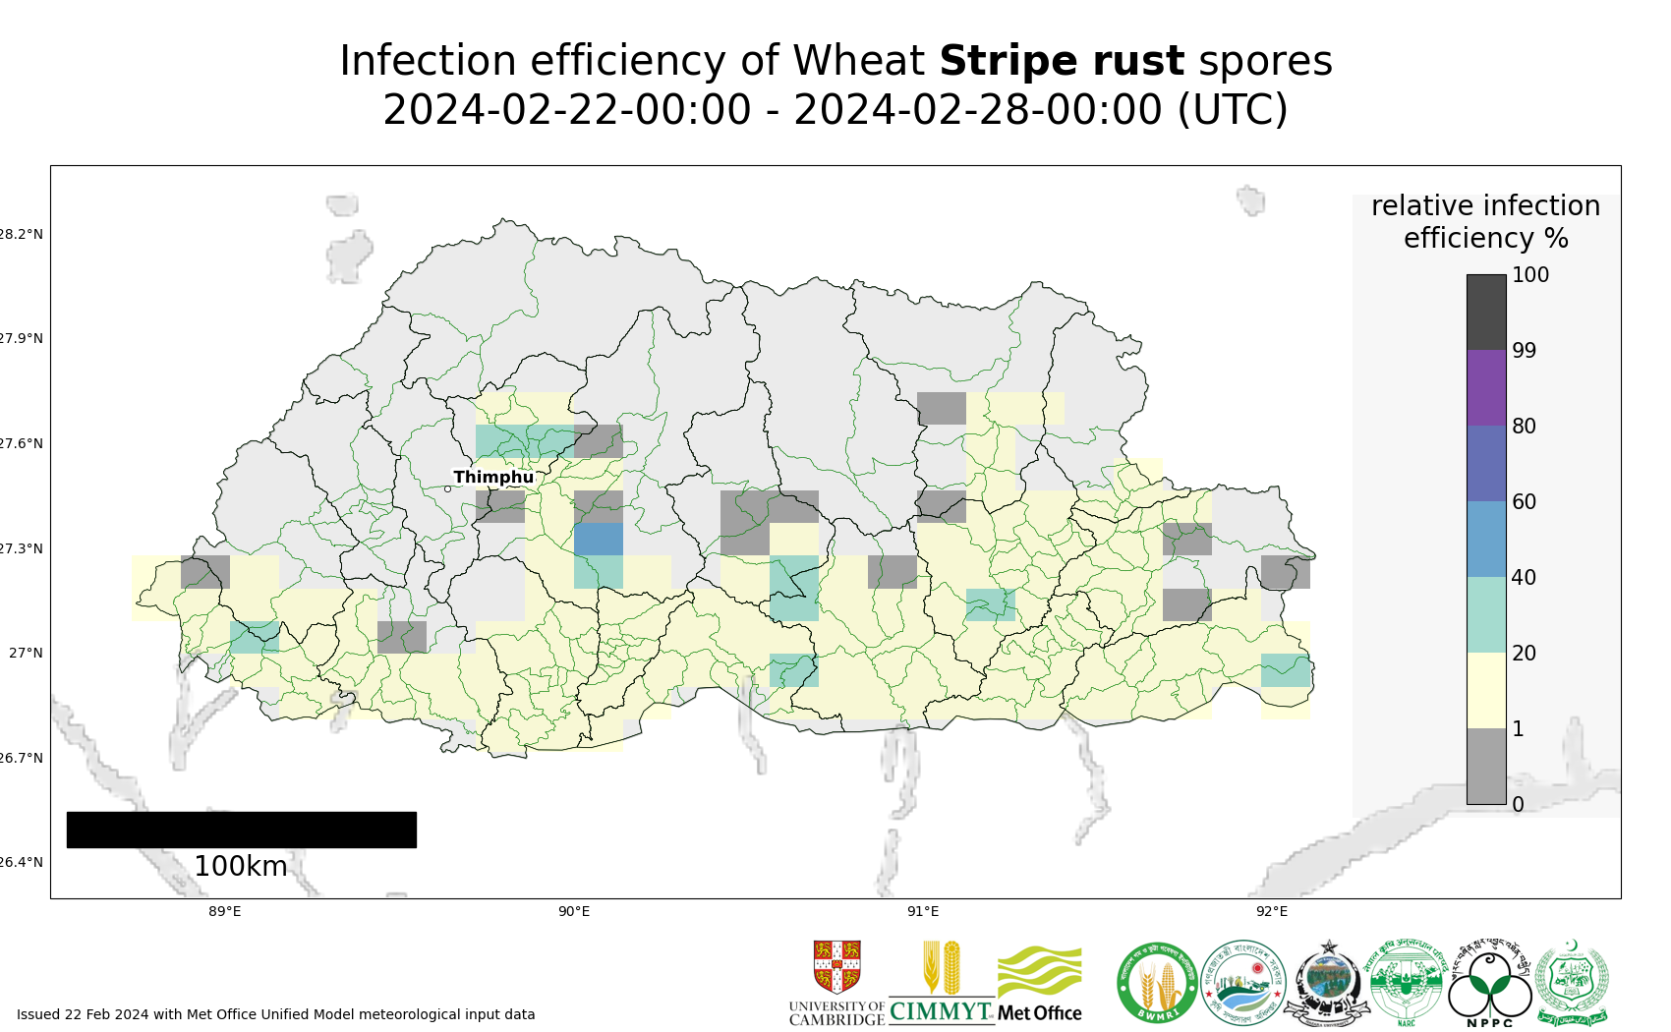
Map 4: Stripe rust suitability for infection forecast Bhutan 22 Feb - 27 Feb 2024
The 20 most impacted districts (infection efficiency) are presented in the table below. The information however should be considered along with presence of wheat, the growth stage and resistance level of the host.
admin2Name | RIE_stripe_rust_%
Chhubu | 21
Dungtoe | 21
Lingmukha | 20
Dzoma | 20
Phangyuel | 20
Chargharay | 19
Daga | 19
Patakla | 18
Dorokha | 18
Mongar | 17
Drepung | 17
Chhali | 17
Gosarling | 16
Namgyel Chhoeling | 16
Shemjong | 16
Denchhukha | 16
Yoeseltse | 16
Chengmari | 16
Langchhenphu | 16
Ruepisa | 16

Stem rust
Dispersal: Current forecast (22 Feb - 28 Feb) indicates no dispersal as no reports of stem rust.
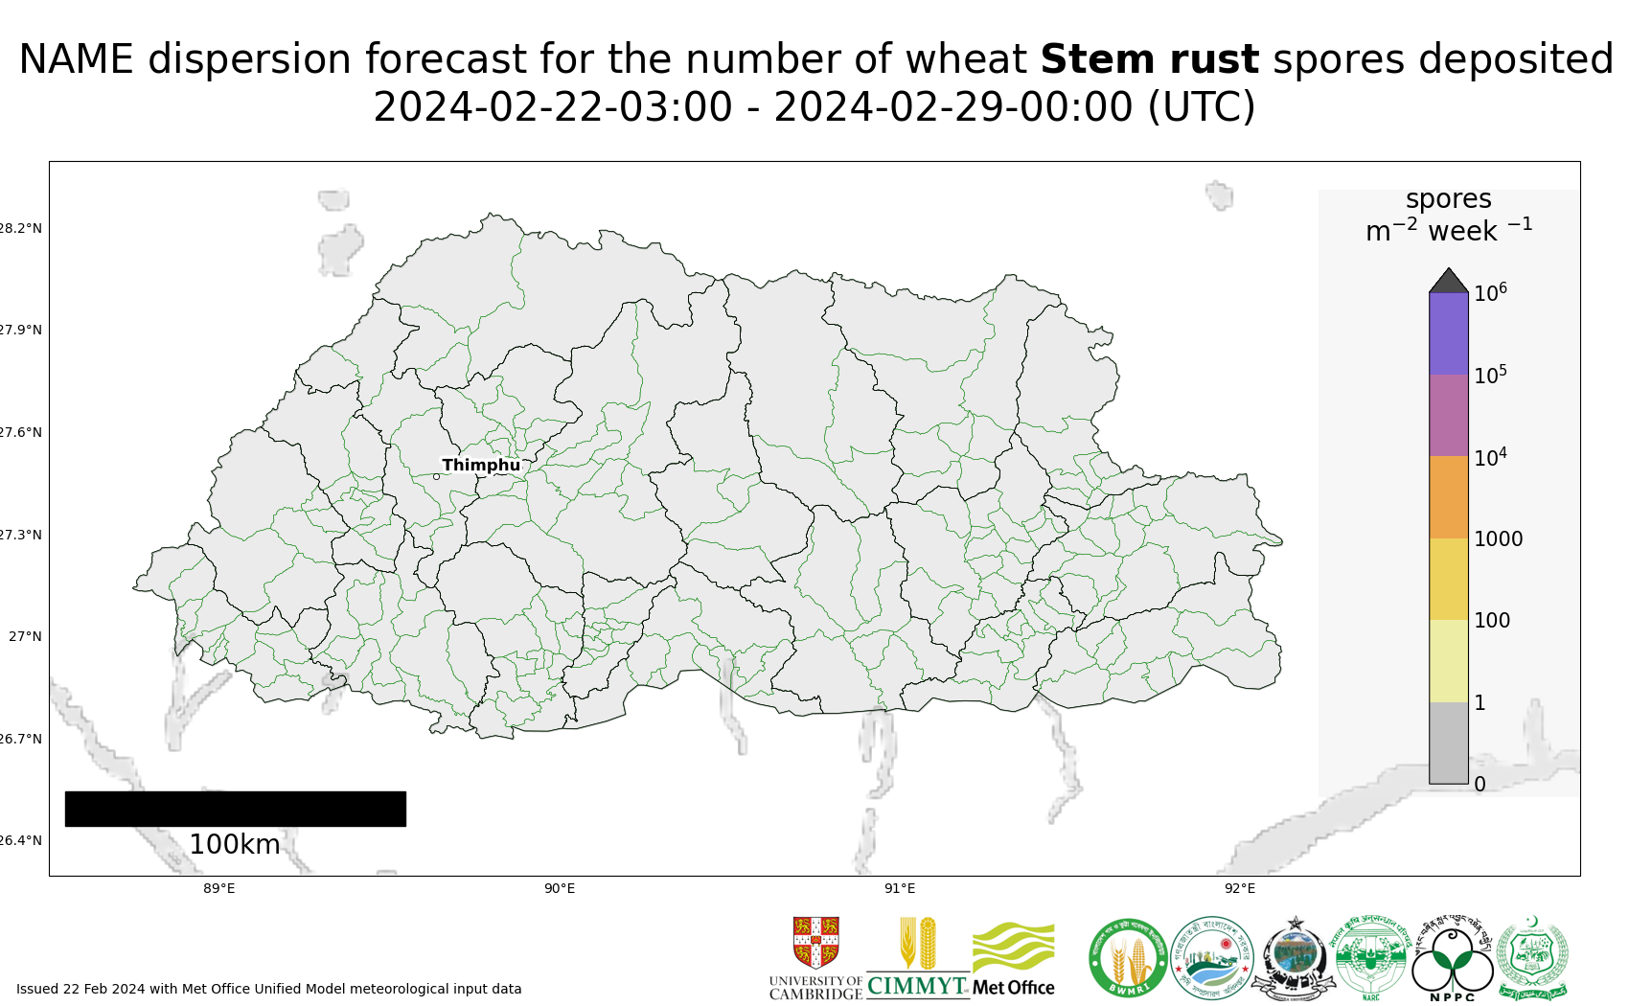
Map 5: Stem rust spore deposition forecast Bhutan 22 Feb - 28 Feb 2024
Risk of infection: Current forecast (22 – 27 Feb) indicates generally low infection efficiency, with some small pockets of moderate infection efficiency in lowland southern areas.
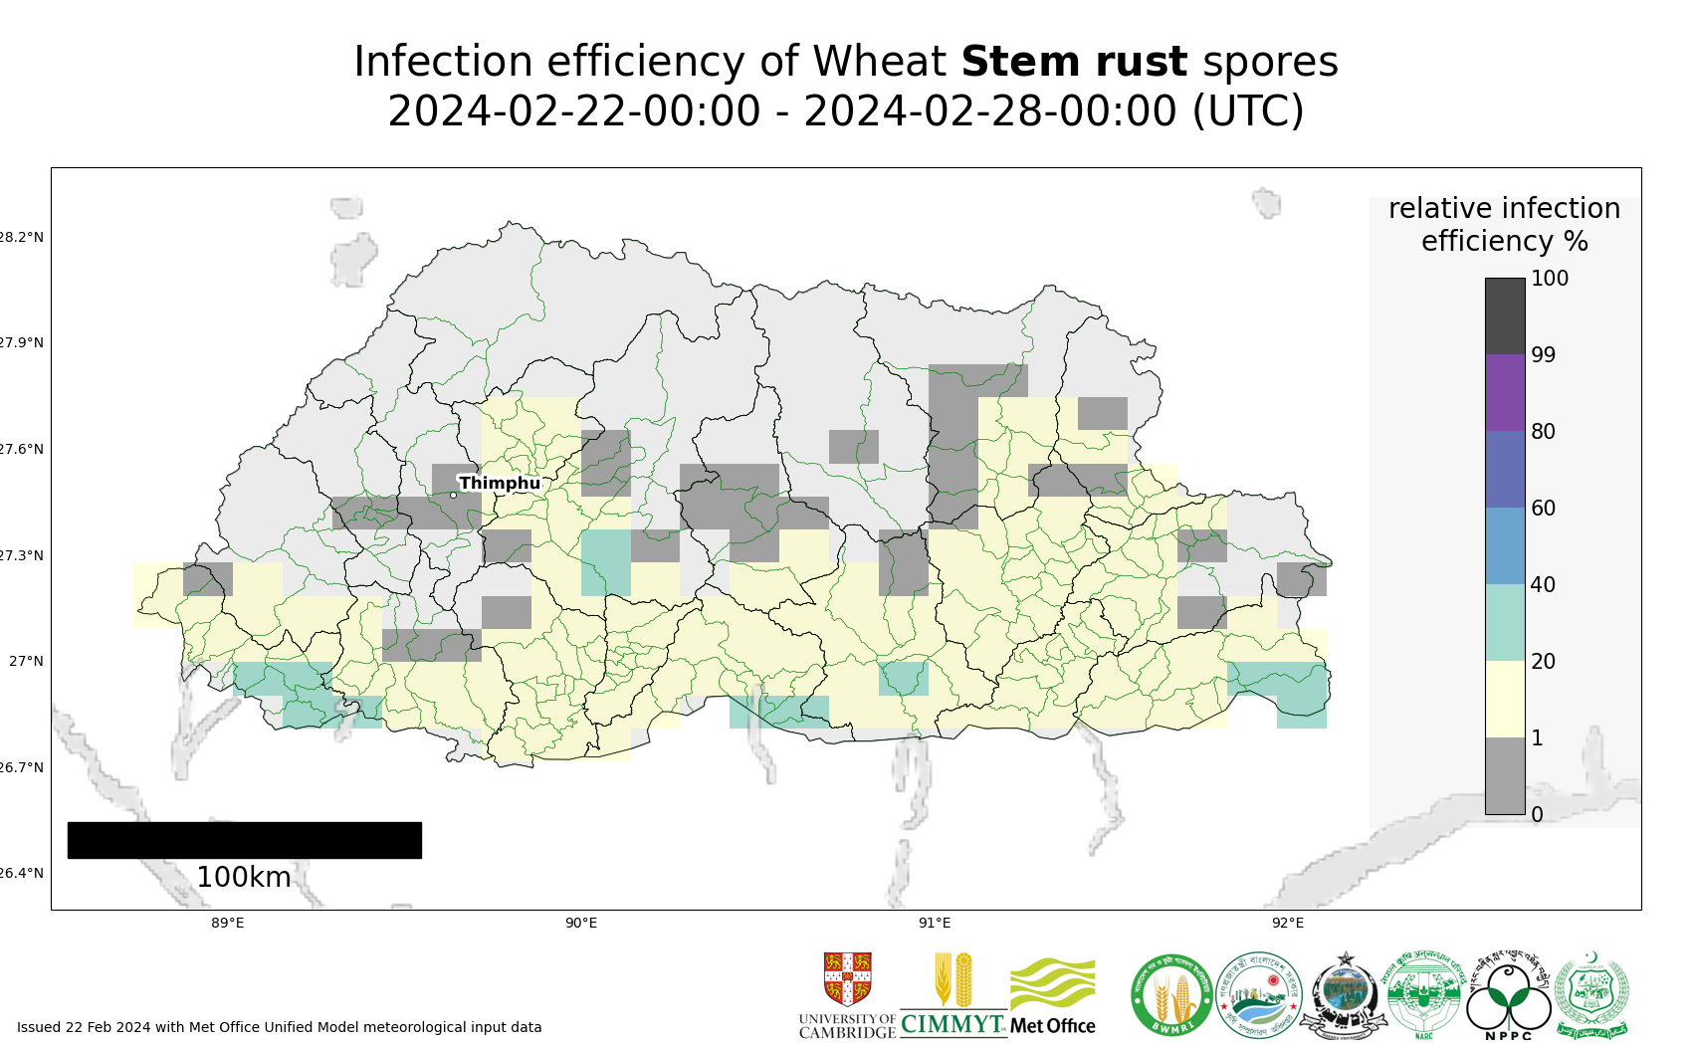
Map 6: Stem rust suitability for infection forecast Bhutan 22 Feb - 27 Feb 2024
The 20 most impacted districts (infection efficiency) are presented in the table below. The information however should be considered along with presence of wheat, the growth stage and resistance level of the host.

admin2Name | RIE_stem_rust_%
Pagli | 33
Samtse | 32
Ugentse | 30
Langchhenphu | 28
Tading | 26
Umling | 26
Samphelling | 25
Dorokha | 23
Gelephu | 23
Chhuzagang | 23
Sherzhong | 22
Taklai | 22
Chengmari | 22
Yoeseltse | 22
Bhur | 21
Dekiling | 21
Phuentsholing | 21
Pangkhar | 20
Gozhing | 20
Barzhong | 19

Regional Forecasts – Precipitation & Temperature
Forecasts from the National Centers for Environmental Prediction (NCEP)[ http://wxmaps.org/pix/clim]
These indicate possible general conditions across South Asia, with likely decreasing prediction accuracy in the second forecast period.
During the period 22 Feb – 1Mar, light rain is forecast for northern Pakistan, north-west India, the higher hill areas of Nepal, Bhutan and Bangladesh. Moderate rain is forecast for the southwest of Pakistan. During the period 1 – 9 Mar, increased rain is forecast for northern Pakistan, Northwest India and the western hills of Nepal. Moderate to light rain is forecast across other areas of Pakistan, except the southeast. Some light rain forecast for Bhutan and northern Bangladesh.

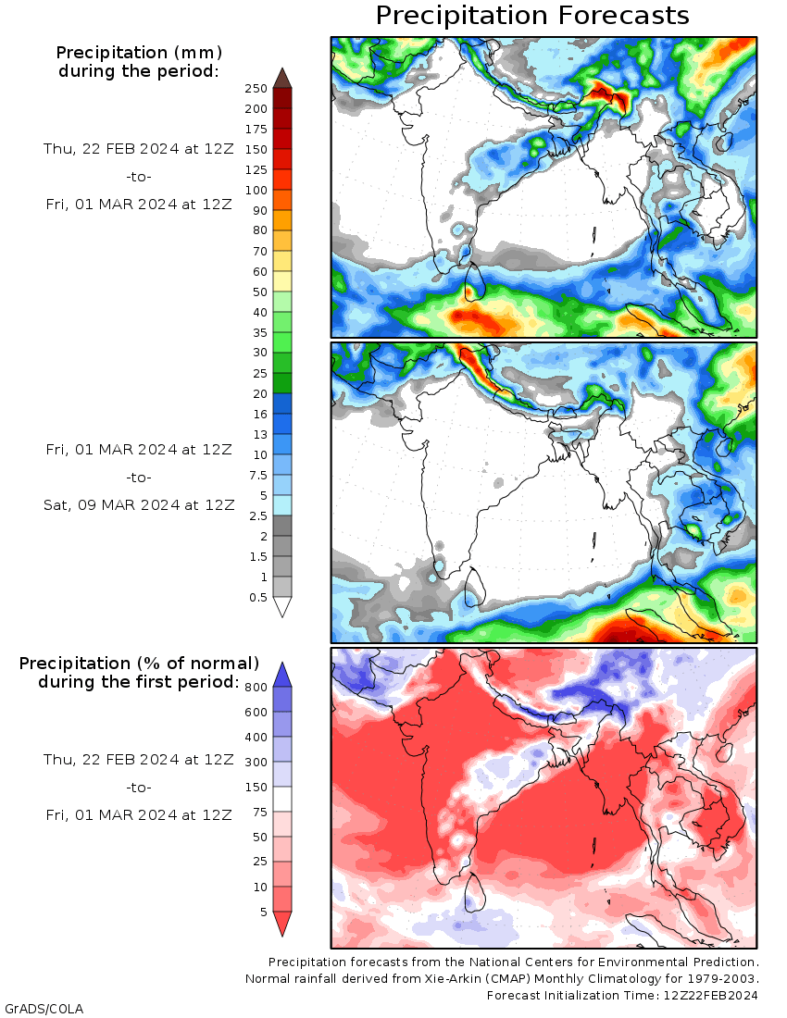
Temperature: During the period 22 Feb - 1 Mar, cooler conditions are forecast in the far north of Pakistan, southwest of Pakistan, north west India, the high hills of Nepal and Bhutan. Increasing warmer temperatures are forecast elsewhere. A similar pattern of temperatures, but with increased warming notably in Bangaldesh, is forecast during the period 1 -9 Mar.

