

Wheat rust advisory - risk assessment from surveys and forecasts in Bhutan

Summary period: 28 Feb - 05 Mar 2024

Overall risk level:
Caution / Low

Key messages
Current situation is calm, but forecast models indicate increasing risk of infection. Lowland areas in the south have the highest forecast infection efficiency, especially for leaf rust (and potentially stem rust). Mid hills and some northern valleys are forecast to have risk for stripe rust infections.

Very low spore density deposition for leaf and stripe rust is forecast across Bhutan (but this probably unlikely to result in infections)

During the period 29 Feb – 8 Mar, some light rain is forecast for most areas of Bhutan. This may continue in the higher hill areas during 8 – 16 Mar. moderate rain is forecast for Bhutan and light rain continuing during 1 – 9 Mar. Temperatures are forecast to be relatively cool for 29 Feb – 8Mar in highland areas, but with warming in southern areas and major valleys.

These weather conditions may be favorable for the development of rusts, especially leaf rust in more southern areas and stripe rust in mid hills and valleys.

Recommendations
Suitable conditions for leaf rust (lower, warmer areas) and stripe rust (cooler higher areas) are likely to develop due to forecast rain over the next 1-2 weeks. Scouting should be undertaken and farmers informed to be vigilant for the emergence of rust. If rust starts to appear farmers should be advised to undertake control if susceptible cultivars are grown.
The risk however is based on susceptible wheat lines. Different levels of resistance will reduce the risk of the disease at the farmer field. Before the decision on the use of fungicide, pls consider advisory from expert in your area.
- Awareness should be raised amongst stakeholders at all levels, including farmers, to be vigilant for early appearance of rusts. Early control to stop increased spread and further build-up of disease is very important.
- Sampling should be undertaken to determine races of rust present.

Field surveys
No surveys are available in this region yet.

Spore dispersal forecasts
Spore dispersal forecasts run by the UK Met Office and Cambridge University are displayed for stem, stripe and leaf rusts for the forecasted period. Surveys in each district are gathered to provide a single source per administrative area for dispersal forecasts (red dots in figure).

Environmental / climatic suitability for infection forecasts
These forecasts give the probability of wheat rust infection occurring based on meteorological factors. The maximum infection efficiency that can occur is 100%. This means that 100% of the spores deposited on susceptible wheat plants could complete the infection process. Therefore, a forecast Infection Efficiency of 100% indicates the highest risk of wheat rust infection occurring in susceptible wheat varieties.

Leaf rust
Dispersal: Current forecast (28 Feb - 05 Mar) indicates low density spore deposition from infected sites in Bangladesh across the southern part of Bhutan.
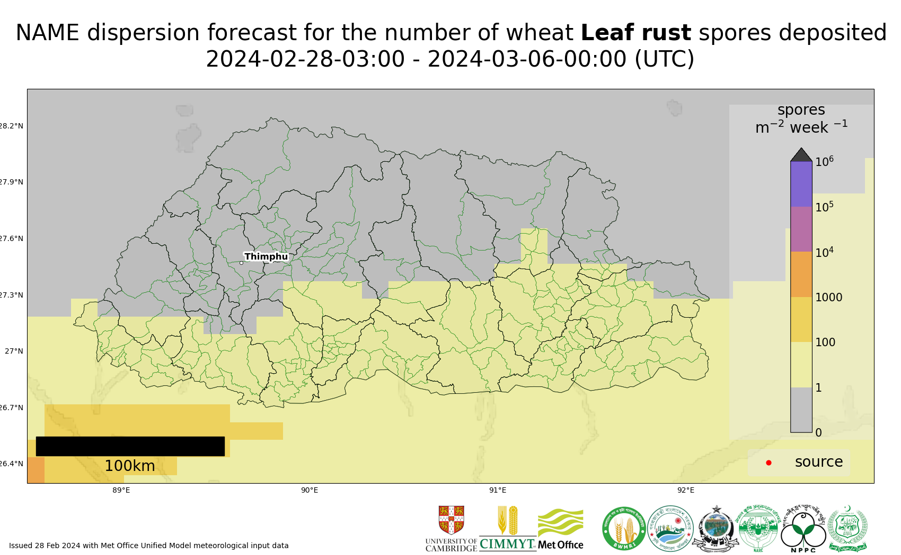
Map 1: Leaf rust spore deposition forecast Bhutan 28 Feb - 05 Mar 2024
The 20 most impacted districts (spore deposition) are presented in the table below.
admin2Name | Leaf rust spores per m^2 per week
Lhamoizingkha | 62
Pagli | 48
Dala | 45
Samphelling | 41
Nichula | 36
Deorali | 36
Senge | 33
Taklai | 29
Dorona | 28
Tsendagang | 27
Shompangkha | 26
Umling | 24
Beteni | 23
Chhuzagang | 23
Sherzhong | 23
Gelephu | 23
Bhur | 23
Bongo | 22
Dekiling | 21
Pangkhar | 21
Risk of infection: Current forecast (28 Feb – 4 Mar) indicates increased risk of infection, with high or moderate infection efficiency in lowland southern areas.
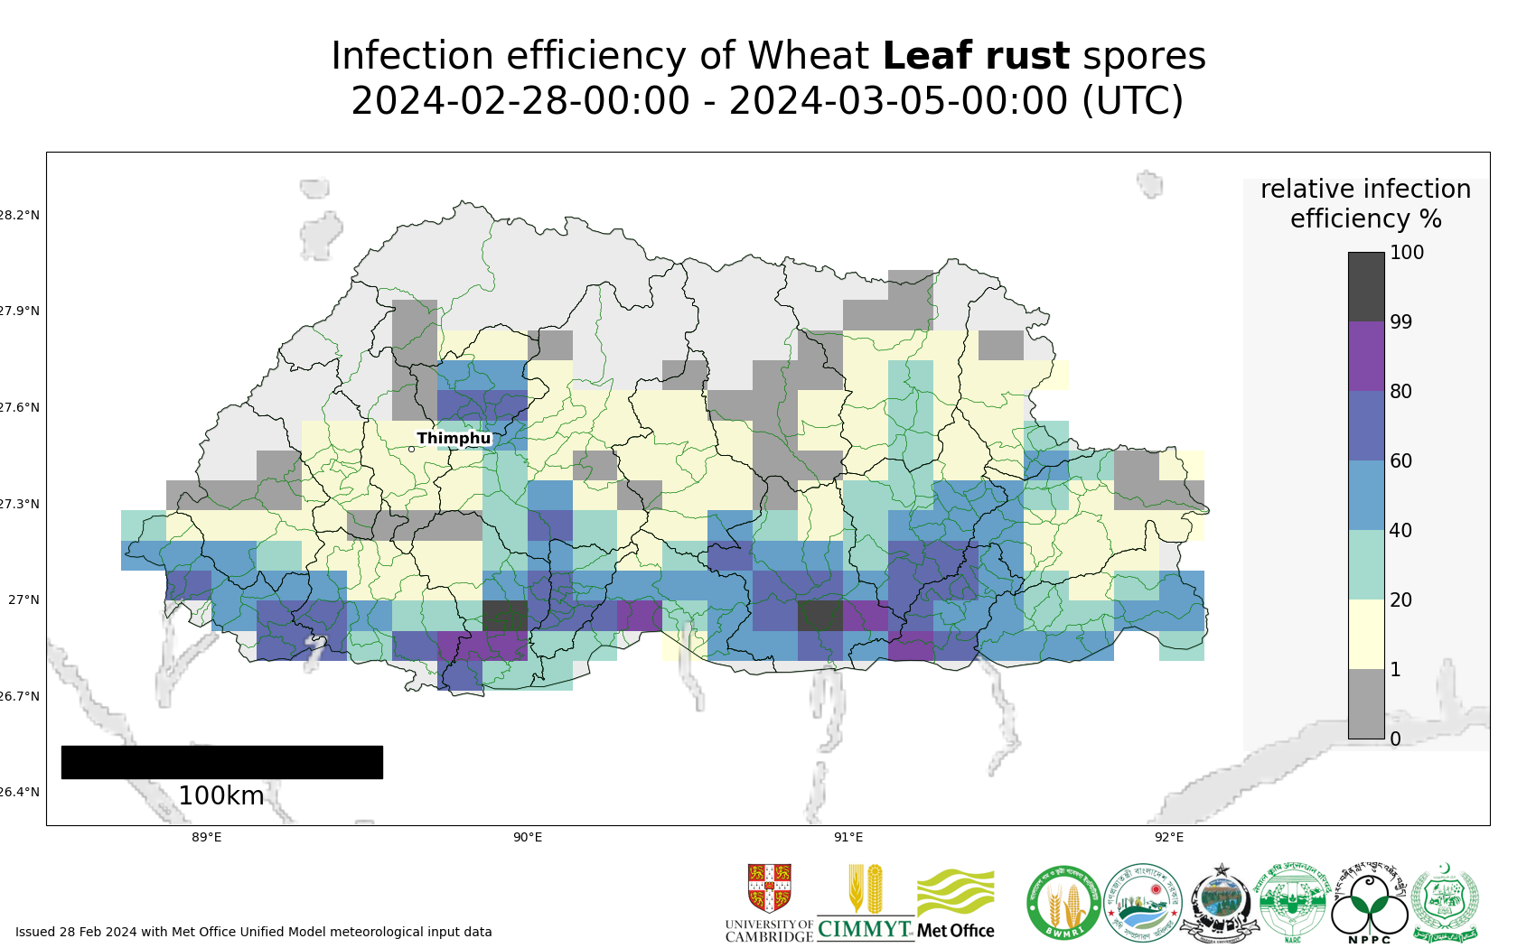
Map 2: Leaf rust suitability for infection forecast Bhutan 28 Feb - 04 Mar 2024
The 20 most impacted districts are presented in the table below. The information however should be considered along with presence of wheat, the growth stage and resistance level of the host.
admin2Name | RIE_leaf_rust_%
Gozhi | 91
Gozhing | 79
Tsholingkhor | 76
Tsangkha | 76
Gesarling | 74
Drugyelgang | 74
Rangthangling | 73
Trashiding | 73
Barzhong | 72
Jurmey | 72
Yurung | 71
Ngangla | 70
Mendrelgang | 70
Pagli | 69
Dungmin | 68
Bjoka | 68
Chhimung | 68
Dorona | 68
Kikorthang | 67
Dechhenling | 67

Stripe rust
Dispersal: Current forecast (28 Feb - 05 Mar) indicates low density spore deposition across Bhutan from infected sites in Nepal.
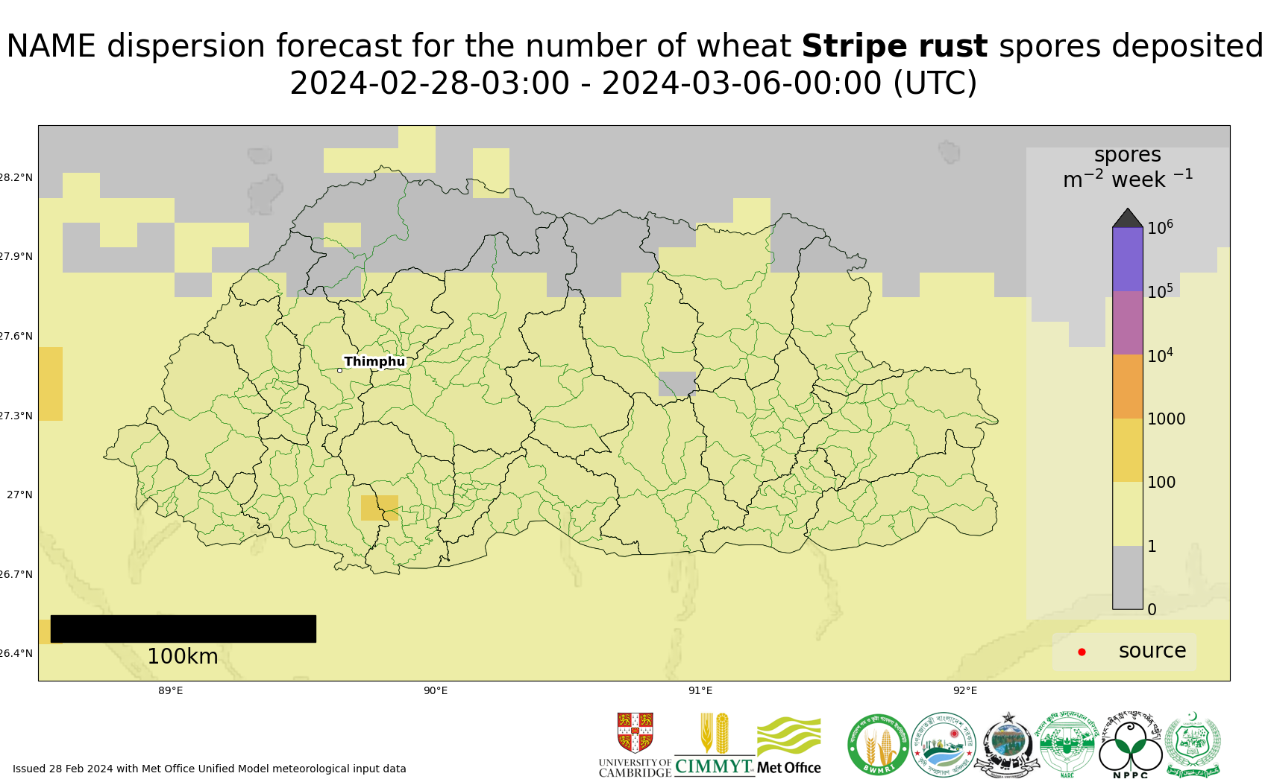
Map 3: Stripe rust spore deposition forecast Bhutan 28 Feb - 05 Mar 2024
The 20 most impacted districts (spore deposition) are presented in the table below.
admin2Name | Stripe rust spores per m^2 per week
Tading | 67
Samphelling | 66
Gesarling | 62
Dorona | 61
Getana | 60
Kalidzingkha | 57
Lhamoizingkha | 57
Phuentsholing | 57
Deorali | 54
Pagli | 53
Dala | 52
Logchina | 51
Bongo | 49
Samtse | 49
Patakla | 49
Denchhukha | 47
Sipsu | 46
Chargharay | 45
Lajab | 45
Namgyel Chhoeling | 45
Risk of infection: Current forecast (28 Feb – 4 Mar) indicates increased risk of infection, with high or moderate infection efficiency in low to mid hills of southern areas. High to moderate infection efficiency in some more northern valleys.
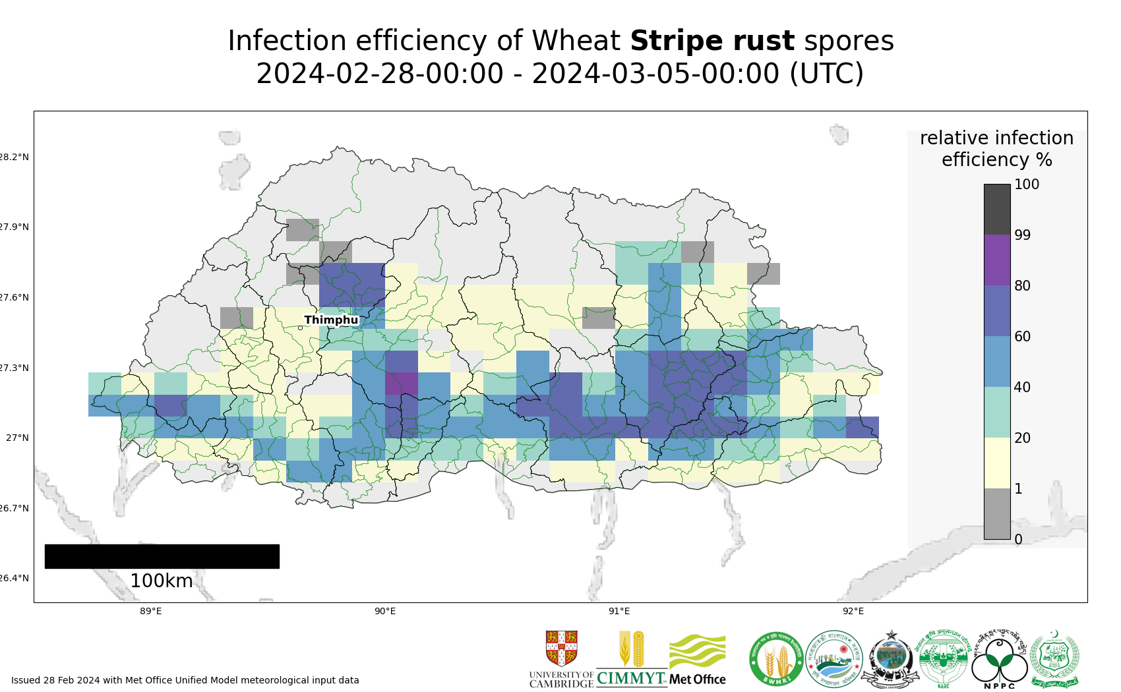
Map 4: Stripe rust suitability for infection forecast Bhutan 28 Feb - 04 Mar 2024
The 20 most impacted districts (infection risk) are presented in the table below. The information however should be considered along with presence of wheat, the growth stage and resistance level of the host.
admin2Name | RIE_stripe_rust_%
Thangrong | 73
Jurmey | 72
Drepung | 72
Kengkhar | 71
Chaskhar | 69
Udzorong | 68
Yurung | 68
Narang | 68
Mongar | 67
Shumer | 65
Chhali | 65
Zobel | 65
Chhubu | 64
Patakla | 64
Tsirangtoe | 63
Gosarling | 63
Shemjong | 63
Silambi | 61
Dungmin | 61
Chhimung | 61

Stem rust
Current forecast (28 Feb - 05 Mar) indicates no dispersal as no reports of stem rust.
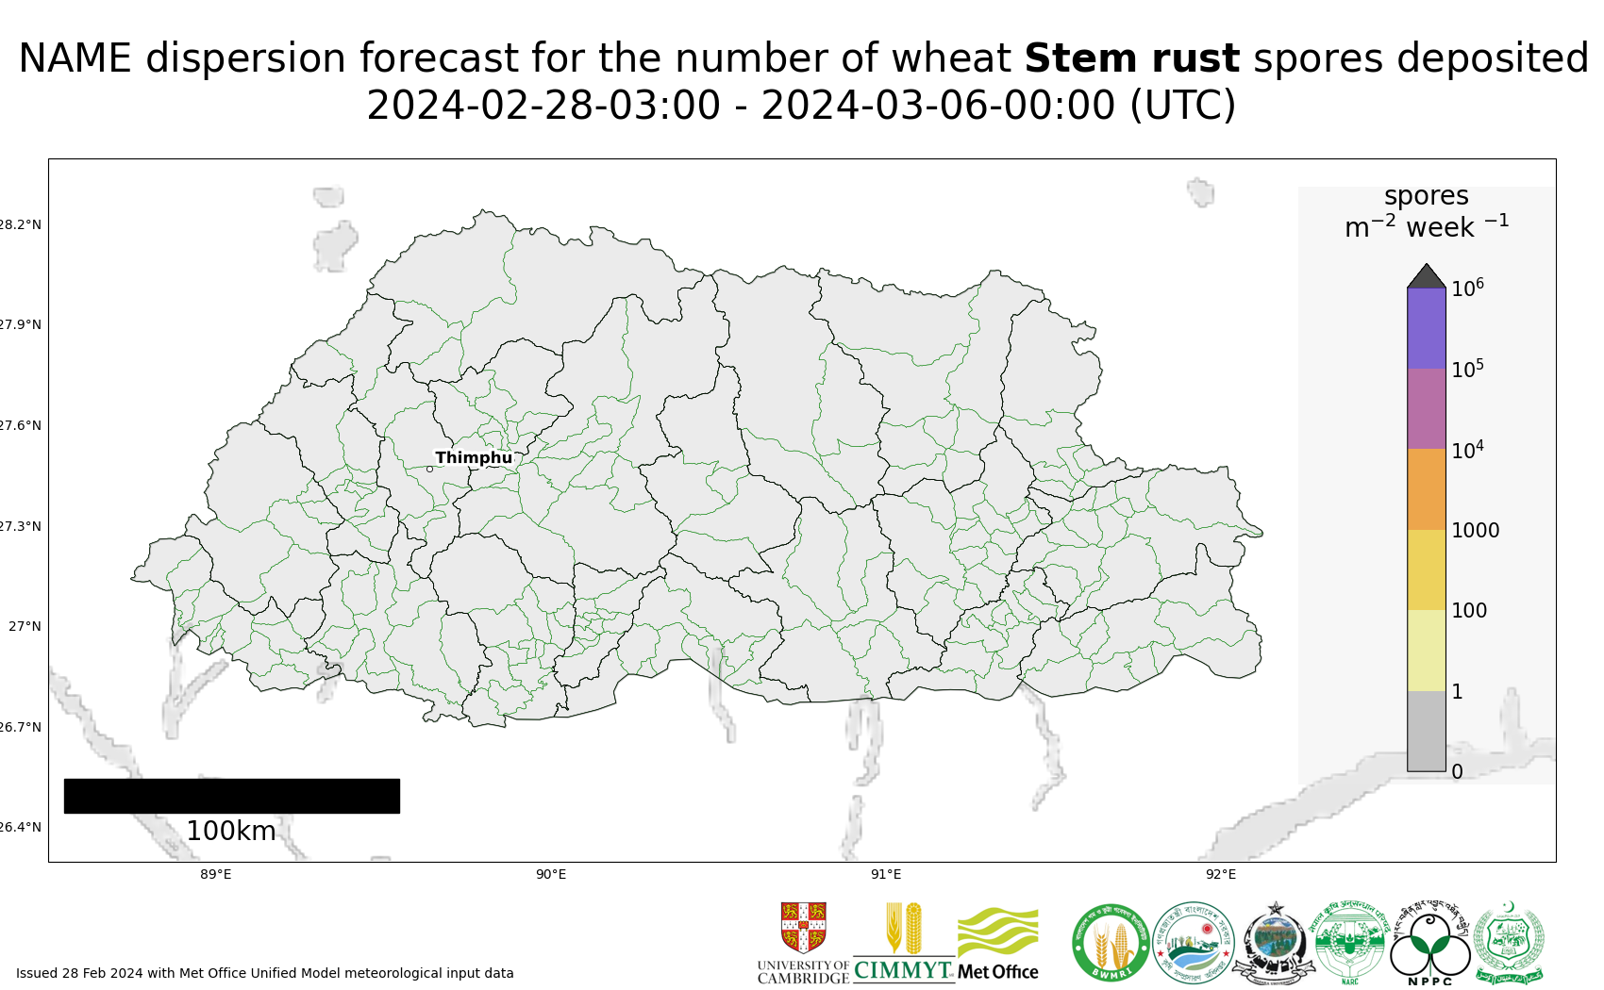
Map 5: Stem rust spore deposition forecast Bhutan 28 Feb - 05 Mar 2024
Risk of infection: Current forecast (28 Feb – 4 Mar) indicates increased risk of infection, with high or moderate infection efficiency in lowland - mid hills in southern areas. Some high-moderate infection risk in more northern valleys.
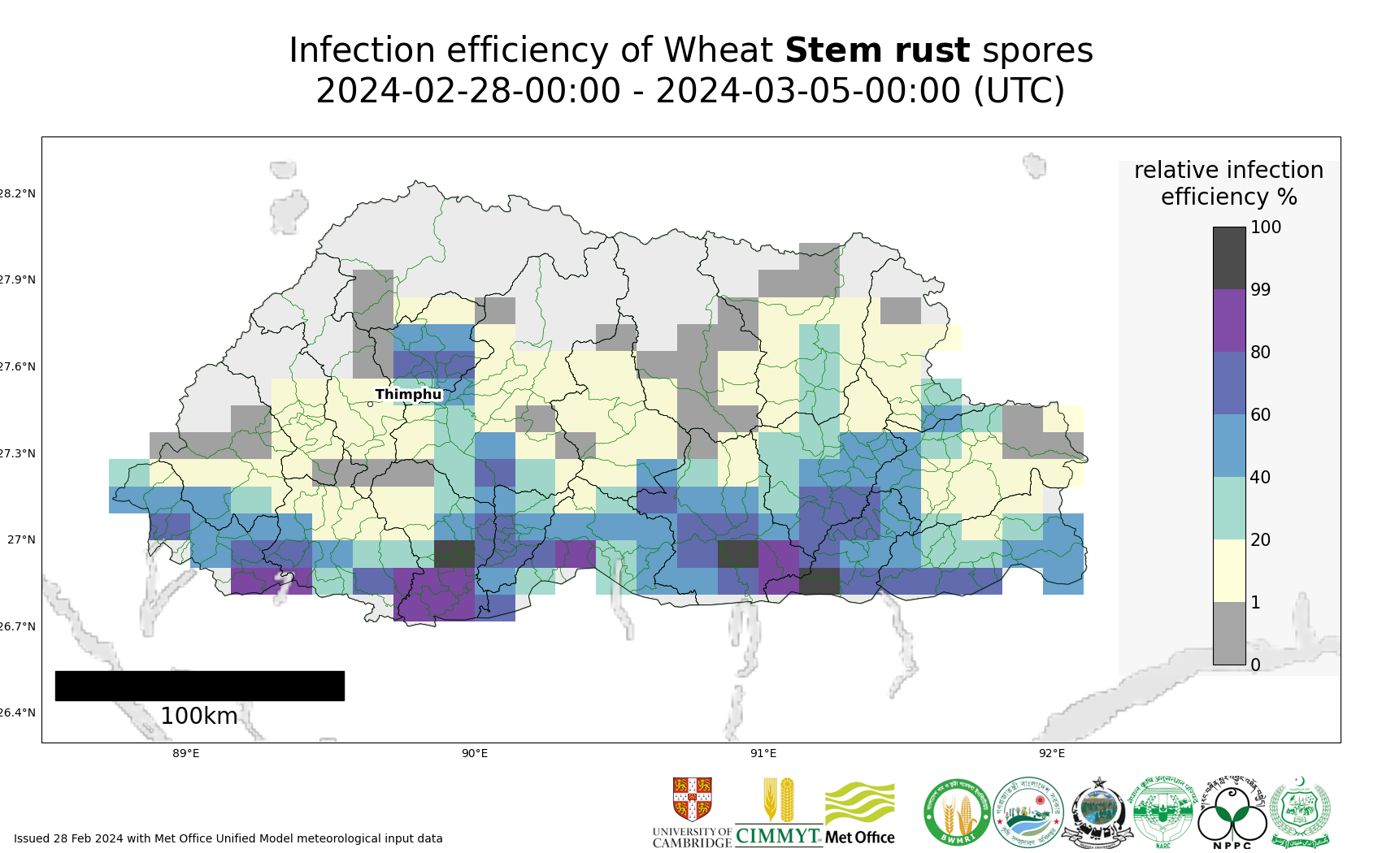
Map 6: Stem rust suitability for infection forecast Bhutan 28 Feb - 04 Mar 2024

The 20 most impacted districts (infection risk) are presented in the table below. The information however should be considered along with presence of wheat, the growth stage and resistance level of the host.
admin2Name | RIE_stem_rust_%
Gozhi | 91
Norbugang | 83
Pagli | 83
Deorali | 82
Lhamoizingkha | 82
Gozhing | 80
Tsendagang | 78
Dorona | 78
Trashiding | 76
Bjoka | 76
Tsholingkhor | 76
Tsangkha | 76
Ngangla | 75
Drugyelgang | 74
Gesarling | 74
Rangthangling | 74
Barzhong | 73
Chokhorling | 73
Dechhenling | 72
Jurmey | 72

Regional Forecasts – Precipitation & Temperature
Forecasts from the National Centers for Environmental Prediction (NCEP)[ http://wxmaps.org/pix/clim]
These indicate possible general conditions across South Asia, with likely decreasing prediction accuracy in the second forecast period.
During the period 29 Feb – 8Mar, heavy rain is forecast for northern Pakistan, northwest India, western Nepal. Moderate rain if forecast over Pakistan, especially in western areas. Light rain is forecast for Bhutan There is possible chance of very light rain in eastern and southern areas of Bangladesh. During the period 8 – 16 Mar, there is increased chance of light rain in eastern / southern Bangladesh. Rain may persist in northern Pakistan and northwest India and some light rain in the hills of Bhutan, but conditions will be dry elsewhere.

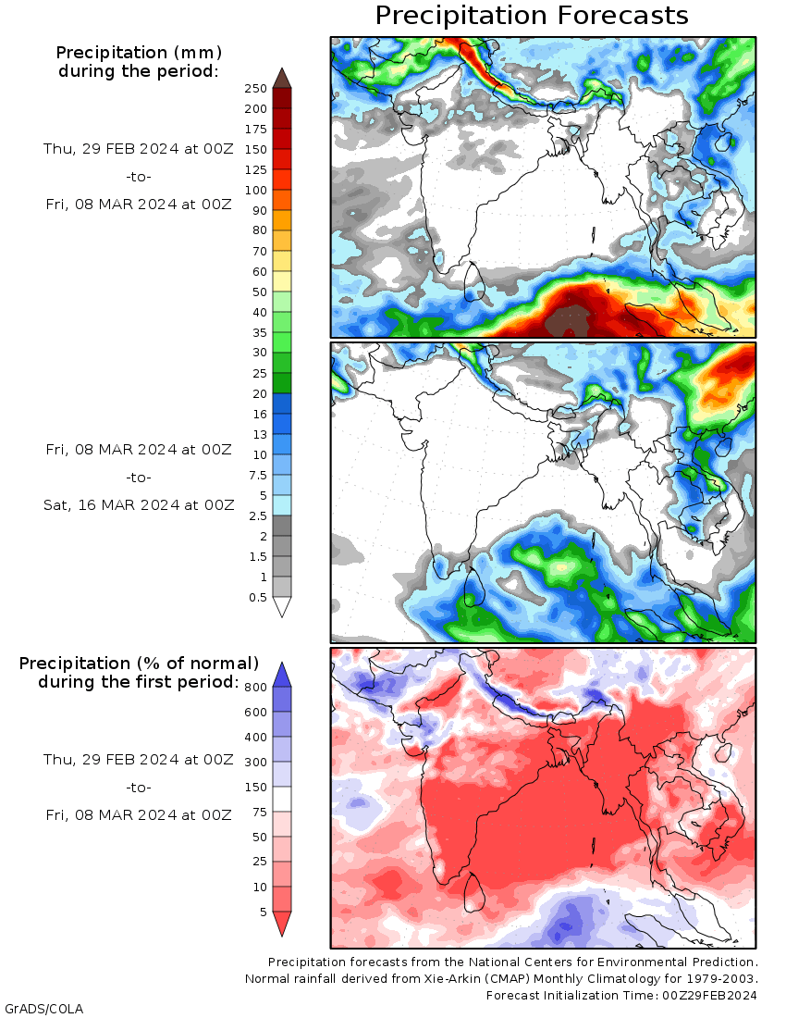
Temperature: During the period 29 Feb - 8 Mar, cooler than normal conditions are forecast over Pakistan, northwest India and the high hills of Nepal and Bhutan. in the far north of Pakistan, southwest of Pakistan, north west India, the high hills of Nepal and Bhutan. Warmer than normal, notably in central to eastern Nepal and western Bangladesh. Increasing, warmer temperatures are forecast during the period 8 -16 Mar.

