

Wheat rust advisory - risk assessment from surveys and forecasts in Bhutan

Summary period: 20 Mar - 26 Mar 2024

Overall risk level:
Caution

Key messages
Forecasts indicate a continued likelihood of spore deposition, both stripe and leaf rust, from neighboring countries. Forecasts for infection efficiency have increased for all of the rusts, especially for southern areas and the main valleys. Close monitoring is recommended for the appearance of either stripe or leaf rust.

During the entire period Mar 21 – 6 Apr some rain is forecast for all of Bhutan. During the period Mar 21 – 29 most areas are forecast to be cooler than normal.

These weather conditions may be favorable for the development of rusts, especially leaf rust in more southern areas and stripe rust in mid hills and valleys.
Given the increased infection efficiency and weather conditions caution and close monitoring is advised.

Recommendations
Suitable conditions for leaf rust (lower, warmer areas) and stripe rust (cooler higher areas) are likely to develop due to forecast rain over the next 1-2 weeks. Scouting should be undertaken and farmers informed to be vigilant for the emergence of rust. If rust starts to appear farmers should be advised to undertake control if susceptible cultivars are grown.
The risk however is based on susceptible wheat lines. Different levels of resistance will reduce the risk of the disease at the farmer field. Before the decision on the use of fungicide, pls consider advisory from expert in your area.
- Awareness should be raised amongst stakeholders at all levels, including farmers, to be vigilant for early appearance of rusts. Early control to stop increased spread and further build-up of disease is very important.
- Sampling should be undertaken to determine races of rust present. This is very important as the new, virulent race of stripe rust (PstS16) may be present in Nepal and an incursion into Bhutan is possible.

Field surveys
No surveys are available in this region yet.

Spore dispersal forecasts
Spore dispersal forecasts run by the UK Met Office and Cambridge University are displayed for stem, stripe and leaf rusts for the forecasted period. Surveys in each district are gathered to provide a single source per administrative area for dispersal forecasts (red dots in figure).

Environmental / climatic suitability for infection forecasts
These forecasts give the probability of wheat rust infection occurring based on meteorological factors. The maximum infection efficiency that can occur is 100%. This means that 100% of the spores deposited on susceptible wheat plants could complete the infection process. Therefore, a forecast Infection Efficiency of 100% indicates the highest risk of wheat rust infection occurring in susceptible wheat varieties.

Leaf rust
Dispersal: Current forecast (20 Mar - 26 Mar) indicates some spore deposition from infected sites in Bangladesh or Nepal into southwestern and southern areas.
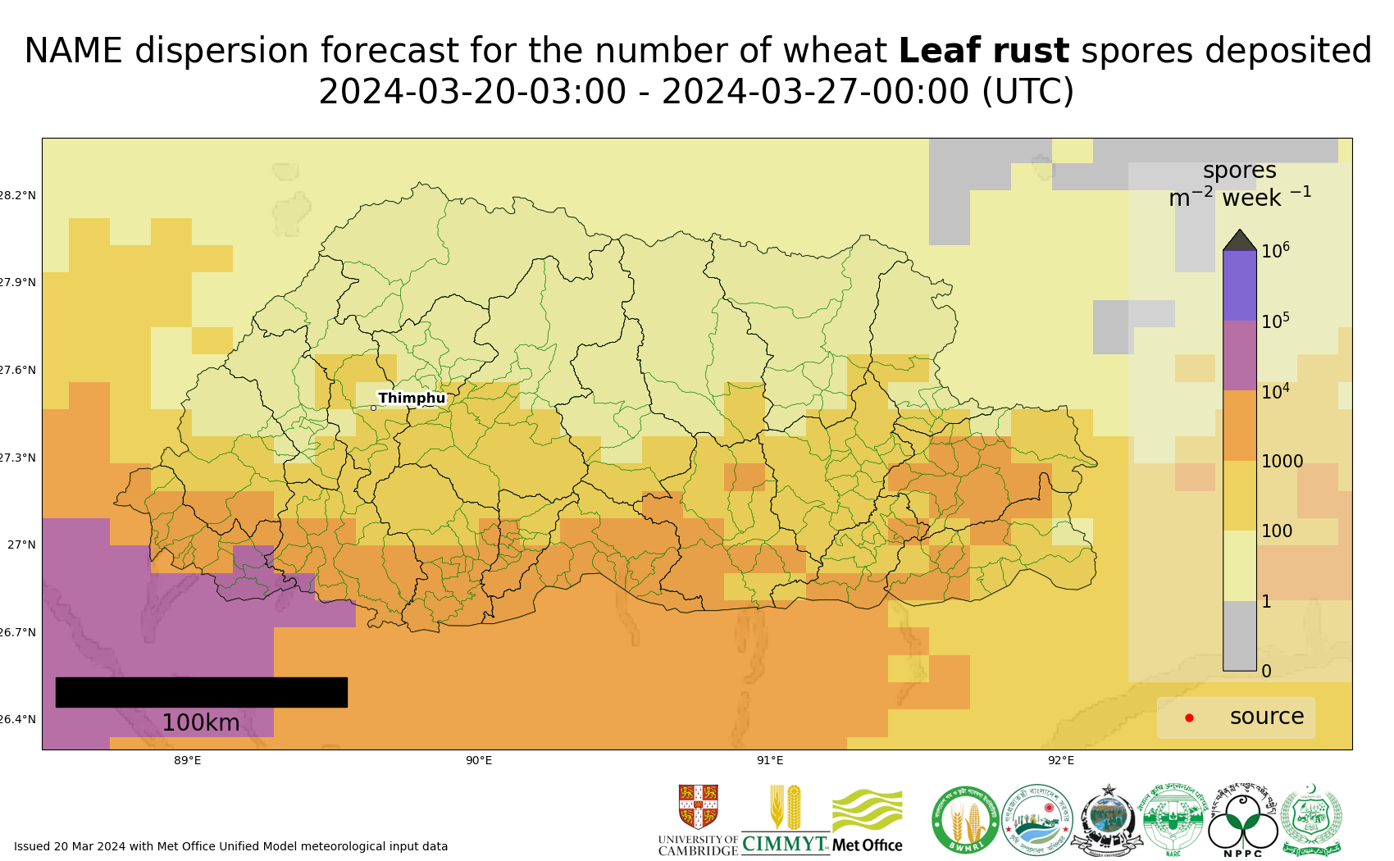
Map 1: Leaf rust spore deposition forecast Bhutan 20 Mar - 26 Mar 2024
The 20 most impacted districts (spore deposition) are presented in the table below.
admin2Name | Leaf rust spores per m^2 per week
Pagli | 12000
Samphelling | 11000
Samtse | 11000
Tading | 11000
Phuentsholing | 9900
Ugentse | 9200
Sipsu | 9100
Dorokha | 8600
Dala | 8500
Yoeseltse | 8200
Chengmari | 7900
Chargharay | 7800
Denchhukha | 7200
Deorali | 6900
Dungtoe | 6700
Bongo | 6700
Lhamoizingkha | 6100
Nichula | 5800
Dorona | 5600
Logchina | 5500

Risk of infection: Current forecast (20 – 25 Mar) indicates increased risk of infection, with high infection efficiency in southern areas.
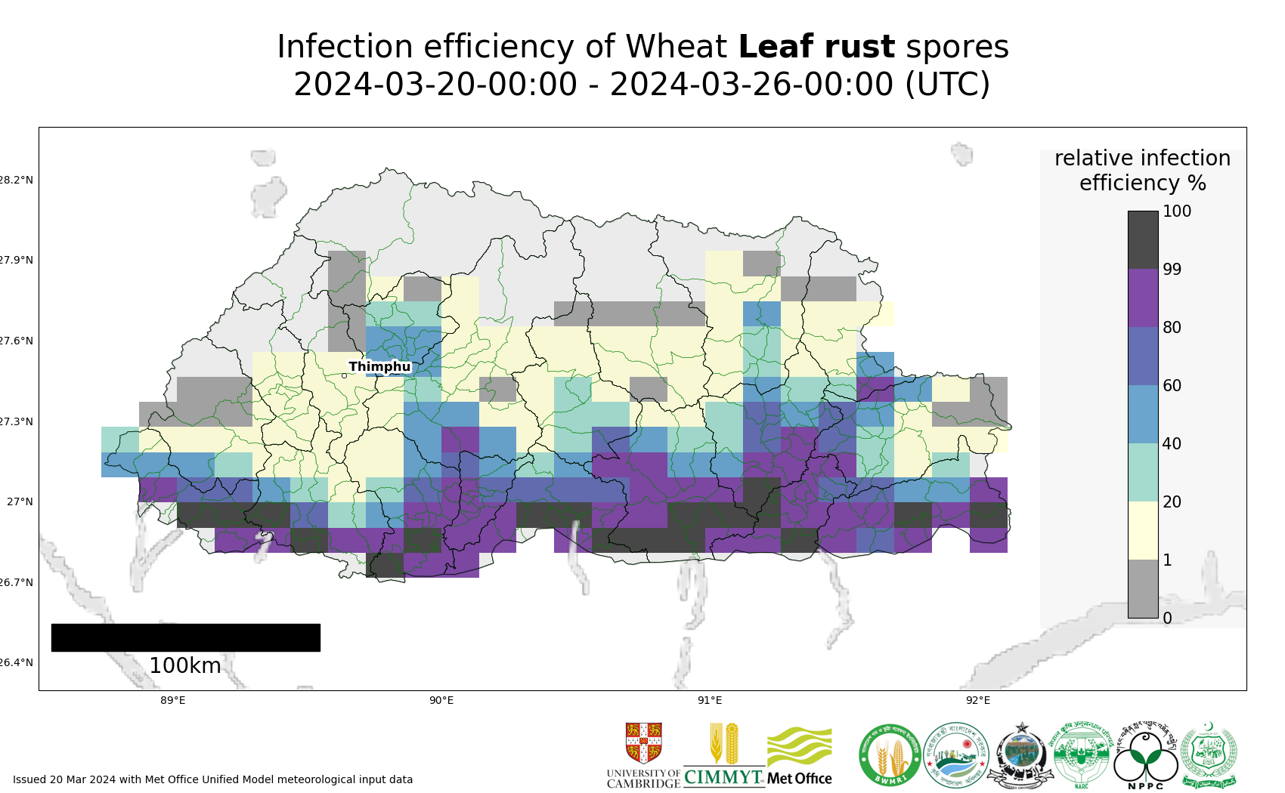
Map 2: Leaf rust suitability for infection forecast Bhutan 20 Mar - 25 Mar 2024
The 20 most impacted districts (infection efficiency) are presented in the table below.
admin2Name | RIE_leaf_rust_%
Ugentse | 100
Trashiding | 99
Gozhing | 99
Shompangkha | 99
Barzhong | 99
Dechhenling | 99
Samtse | 99
Gozhi | 98
Samphelling | 98
Chokhorling | 98
Tading | 98
Chhimung | 98
Beteni | 98
Dungmin | 98
Pagli | 97
Tsendagang | 97
Mendrelgang | 97
Deorali | 97
Pangkhar | 96
Nichula | 96

Stripe rust
Dispersal: Current forecast (20 Mar - 26 Mar) indicates some spore deposition from infected sites in Nepal into southwestern areas.
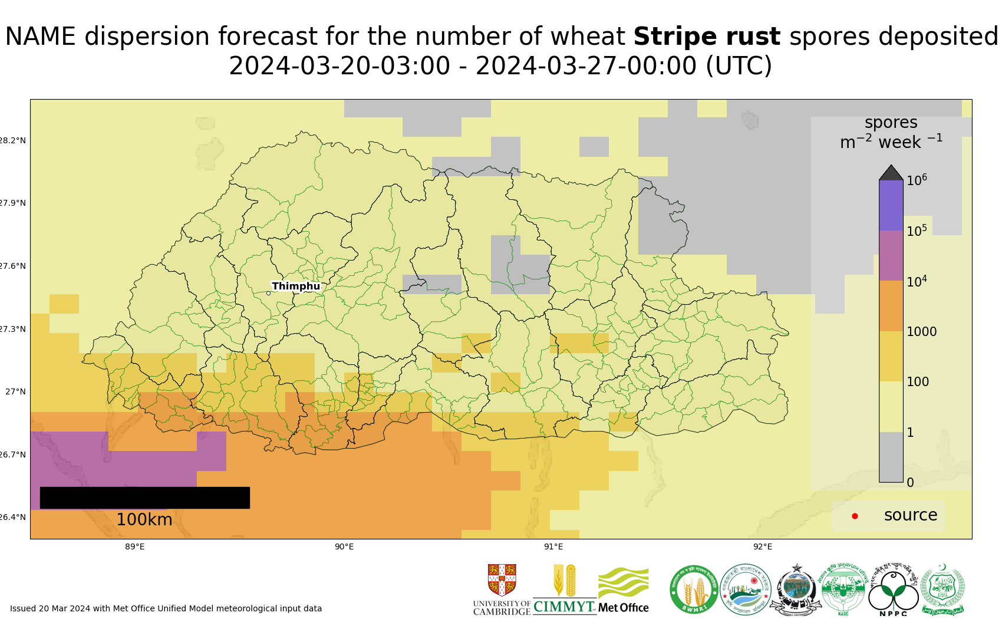
Map 3: Stripe rust spore deposition forecast Bhutan 20 Mar - 26 Mar 2024
The 20 most impacted districts (spore deposition) are presented in the table below.
admin2Name | Stripe rust spores per m^2 per week
Lhamoizingkha | 5700
Samphelling | 5400
Deorali | 5200
Dala | 4800
Nichula | 4400
Pagli | 4100
Dorona | 3700
Bongo | 3000
Getana | 2600
Tading | 2400
Phuentsholing | 2300
Tsendagang | 2300
Senge | 2100
Samtse | 1500
Gozhi | 1200
Gesarling | 1200
Trashiding | 1100
Ugentse | 1100
Shompangkha | 940
Beteni | 910

Risk of infection: Current forecast (20 – 25 Mar) indicates an increase in risk of infection, with high infection efficiency in southern areas and also the main valleys.
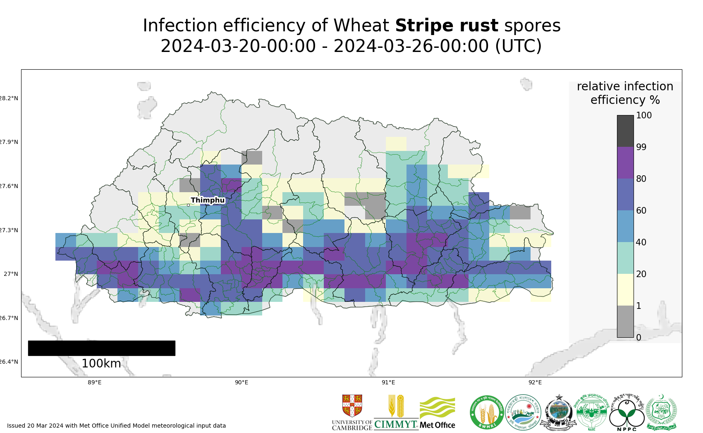
Map 4: Stripe rust suitability for infection forecast Bhutan 20 Mar - 25 Mar 2024
The 20 most impacted districts (infection efficiency) are presented in the table below.
admin2Name | RIE_stripe_rust_%
Tsangkha | 85
Tsholingkhor | 85
Shemjong | 84
Drepung | 84
Tsirangtoe | 84
Dungtoe | 84
Gosarling | 84
Rangthangling | 84
Drugyelgang | 83
Barzhong | 83
Kikorthang | 83
Mendrelgang | 82
Jurmey | 81
Dunglegang | 81
Thangrong | 81
Patakla | 81
Lajab | 81
Dorokha | 81
Dzoma | 80
Lingmukha | 80

Stem rust
Dispersal: Current forecast (20 Mar - 26 Mar) indicates no dispersal as no reports of stem rust.
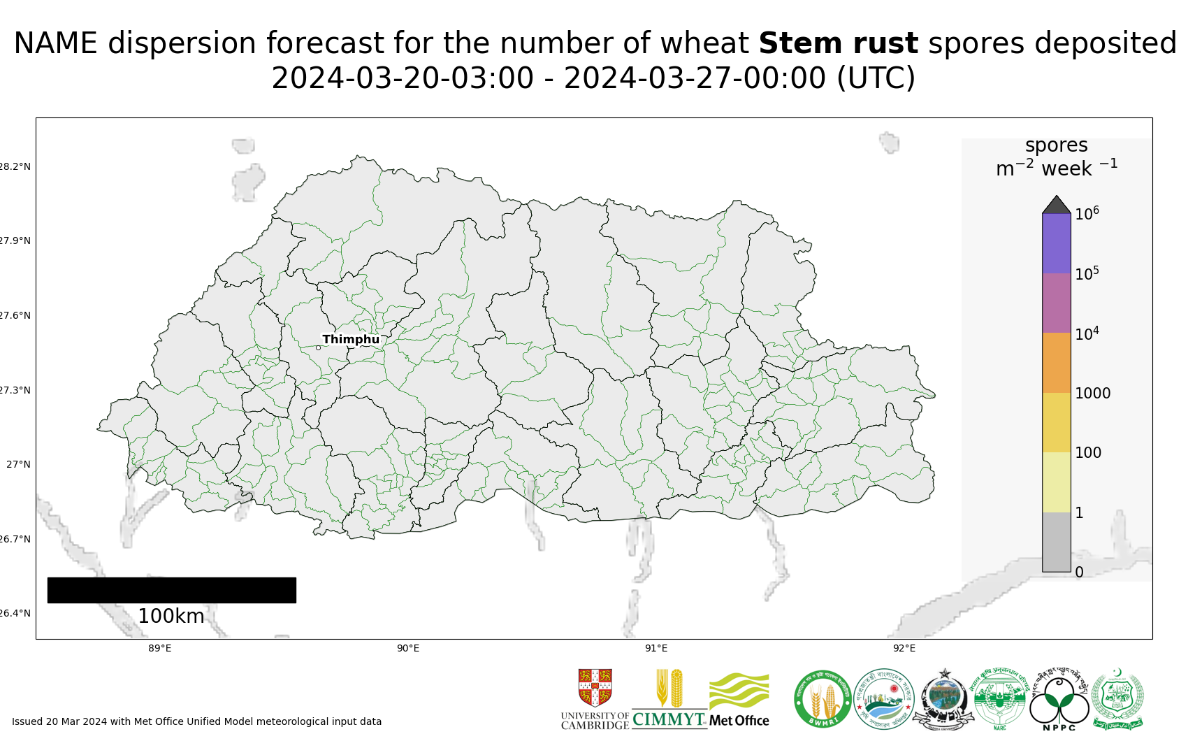
Map 5: Stem rust spore deposition forecast Bhutan 20 Mar - 26 Mar 2024
Risk of infection: Current forecast (20 – 25 Mar) indicates increased risk of infection, with high infection efficiency in southern areas.
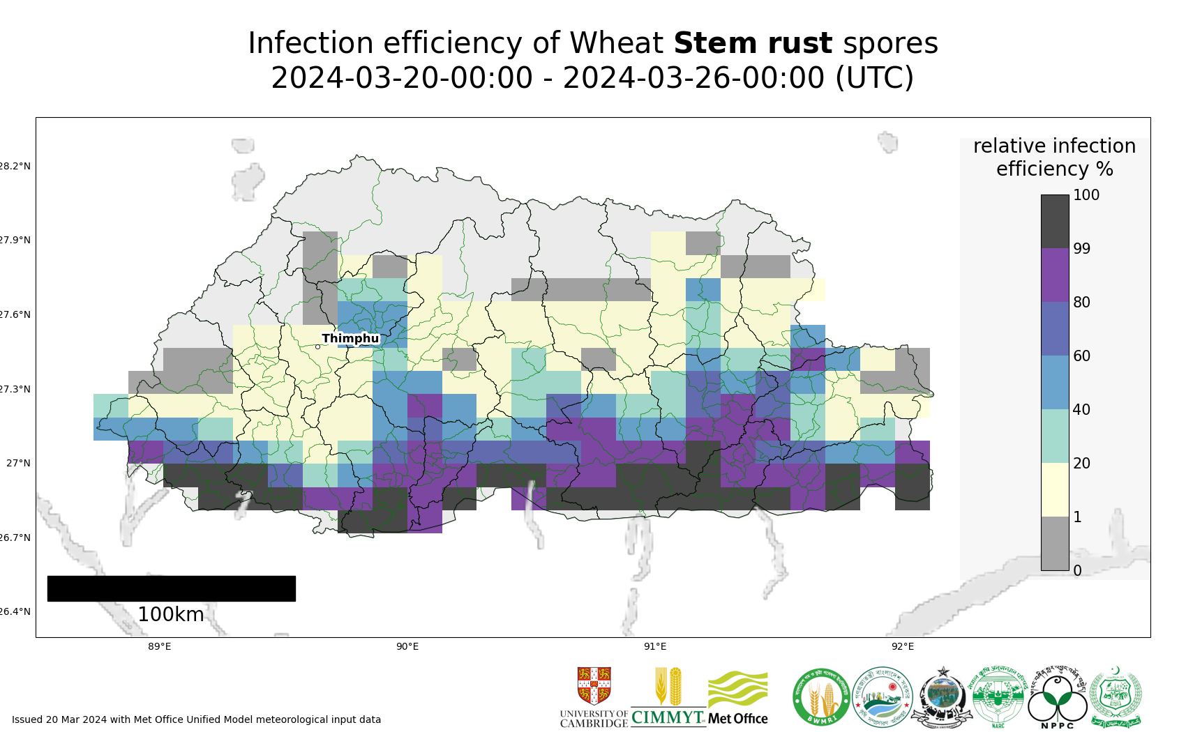
Map 6: Stem rust suitability for infection forecast Bhutan 20 Mar - 25 Mar 2024
The 20 most impacted districts (infection efficiency) are presented in the table below.
admin2Name | RIE_stem_rust_%
Pagli | 100
Norbugang | 100
Shompangkha | 100
Samphelling | 100
Tading | 100
Pemathang | 100
Samtse | 100
Ugentse | 100
Barzhong | 99
Tsendagang | 99
Trashiding | 99
Dechhenling | 99
Nichula | 99
Chokhorling | 99
Deorali | 98
Senge | 98
Dungmin | 98
Chhimung | 98
Gozhing | 98
Lhamoizingkha | 98

Regional Forecasts – Precipitation & Temperature
Forecasts from the National Centers for Environmental Prediction (NCEP)[ http://wxmaps.org/pix/clim]
These indicate possible general conditions across South Asia, with likely decreasing prediction accuracy in the second forecast period.
During the period 21– 29 Mar, rain is forecast for northern/western Pakistan, northwest India, Nepal (especially central /eastern areas), Bhutan and Bangladesh. During the period 29 Mar – 6 Apr, there is increased chance of rain across all these areas.

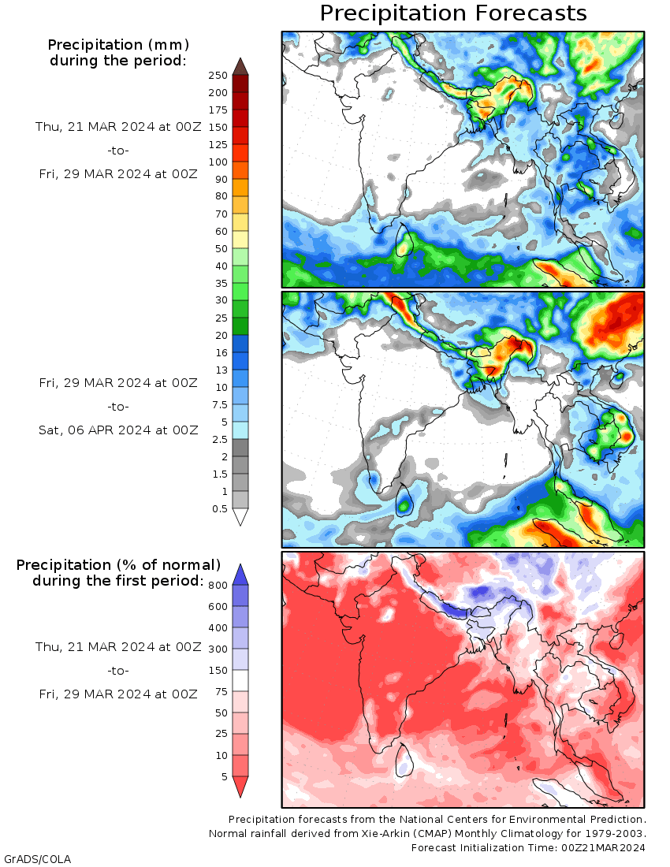
Temperature: During the period 21 - 29 Mar, very warm temperatures across peninsula India and southern / eastern parts of Pakistan. Warmer than normal in the Terai of Nepal. Cooler than normal across Bhutan, Bangladesh and north west India. Similar conditions for 29 Mar – 6 Apr, but increasing, and warmer temperatures for Terai of Nepal and Bangladesh.

