

Wheat rust advisory - risk assessment from surveys and forecasts in Bhutan

Summary period: 04 Feb - 10 Feb 2025

Overall risk level:
Caution / Low

Key messages
Surveys have not yet started in Bhutan. Crops are still at an early stage of development.
Some light rain is forecast during the period 6-14 Feb, which may result in some suitability for disease development – especially stripe rust as temperatures are relatively cool.
Suitability models indicate moderate infection efficiency for rusts across southern areas of Bhutan. Highest stability is indicated for stripe rust.

Recommendations
Very close monitoring of fields, particularly for susceptible varieties, is recommended.
Scouting should be undertaken, especially in southern areas, and farmers informed to be vigilant for the emergence of rust.
- Awareness should be raised amongst stakeholders at all levels, including farmers, to be vigilant for early appearance of rusts. Early control to stop increased spread and further build-up of disease is very important.
- Sampling should be undertaken to determine races of rust present.

Field surveys
No surveys are available in this region yet.

Spore dispersal forecasts
Spore dispersal forecasts run by the UK Met Office and Cambridge University are displayed for stem, stripe and leaf rusts for the forecasted period. Surveys in each district are gathered to provide a single source per administrative area for dispersal forecasts (red dots in figure).

Environmental / climatic suitability for infection forecasts
These forecasts give the probability of wheat rust infection occurring based on meteorological factors. The maximum infection efficiency that can occur is 100%. This means that 100% of the spores deposited on susceptible wheat plants could complete the infection process. Therefore, a forecast Infection Efficiency of 100% indicates the highest risk of wheat rust infection occurring in susceptible wheat varieties.

Leaf rust
Dispersal: Current forecast (04 Feb - 10 Feb) indicates no dispersal as no leaf rust has been detected.
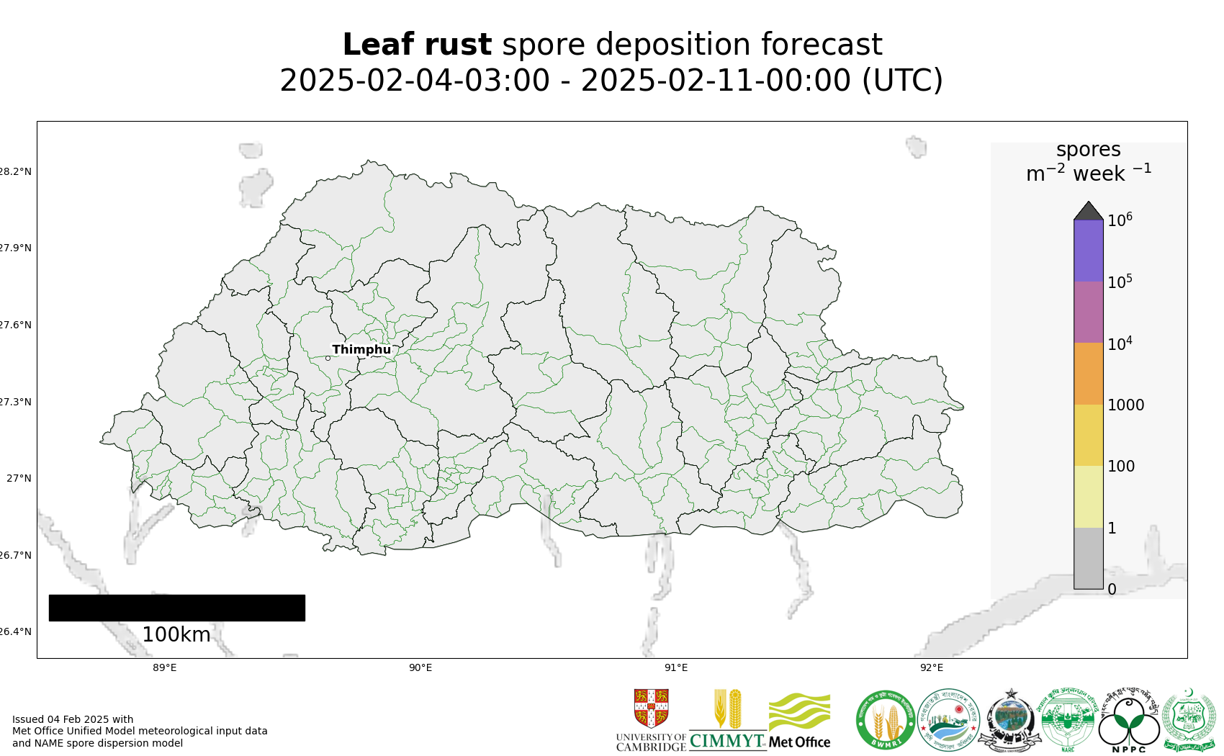
Map 1: Leaf rust spore deposition forecast Bhutan 04 Feb - 10 Feb 2025
Risk of infection: Current forecast (4 – 9 Feb) indicates moderate infection efficiency across southern areas. Little or no suitability forecast in other areas.
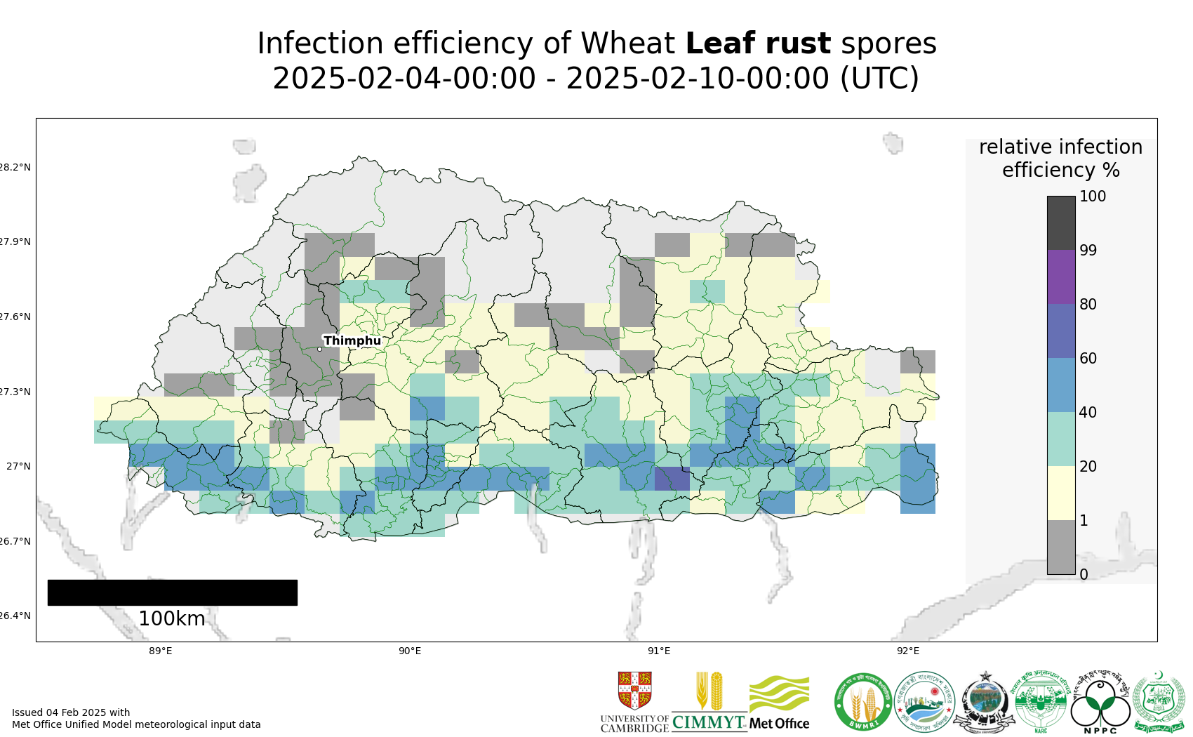
Map 2: Leaf rust suitability for infection forecast Bhutan 04 Feb - 09 Feb 2025

The 20 most impacted districts (infection efficiency) per country are presented in the table below.
admin2Name | admin1Name | RIE_leaf_rust_%
Ugentse | Samtse | 53
Yoeseltse | Samtse | 52
Sipsu | Samtse | 51
Yurung | Pemagatshel | 49
Barzhong | Tsirang | 49
Dorokha | Samtse | 49
Chengmari | Samtse | 48
Tsholingkhor | Tsirang | 47
Tsangkha | Dagana | 47
Chargharay | Samtse | 46
Samtse | Samtse | 46
Ngangla | Zhemgang | 46
Rangthangling | Tsirang | 45
Langchhenphu | Samdrupjongkhar | 45
Mendrelgang | Tsirang | 45
Gozhing | Zhemgang | 45
Samphelling | Chhukha | 45
Dungtoe | Samtse | 45
Denchhukha | Samtse | 44
Shumer | Pemagatshel | 44

Stripe rust
Dispersal: Current forecast (04 Feb - 10 Feb) indicates no dispersal, as no stripe rust detected.
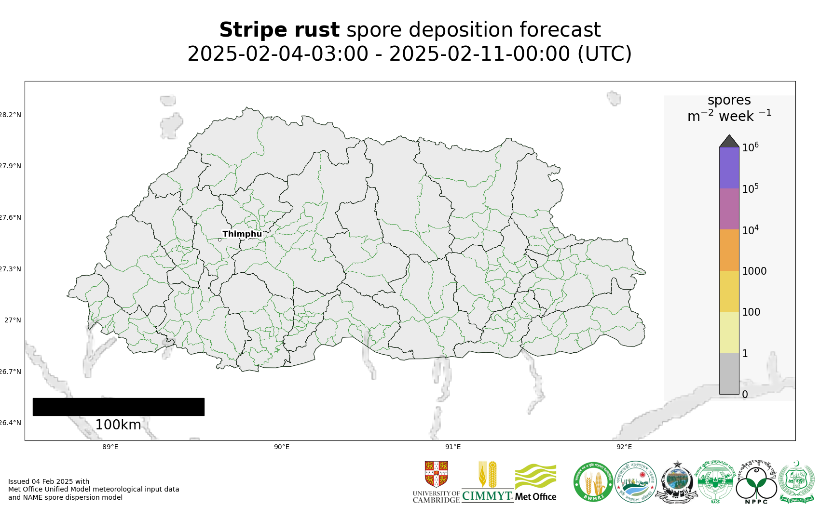
Map 3: Stripe rust spore deposition forecast Bhutan 04 Feb - 10 Feb 2025
Risk of infection: Current forecast (4 – 9 Feb) indicates moderate to high infection efficiency across southern areas. Little or no suitability forecast in other areas.
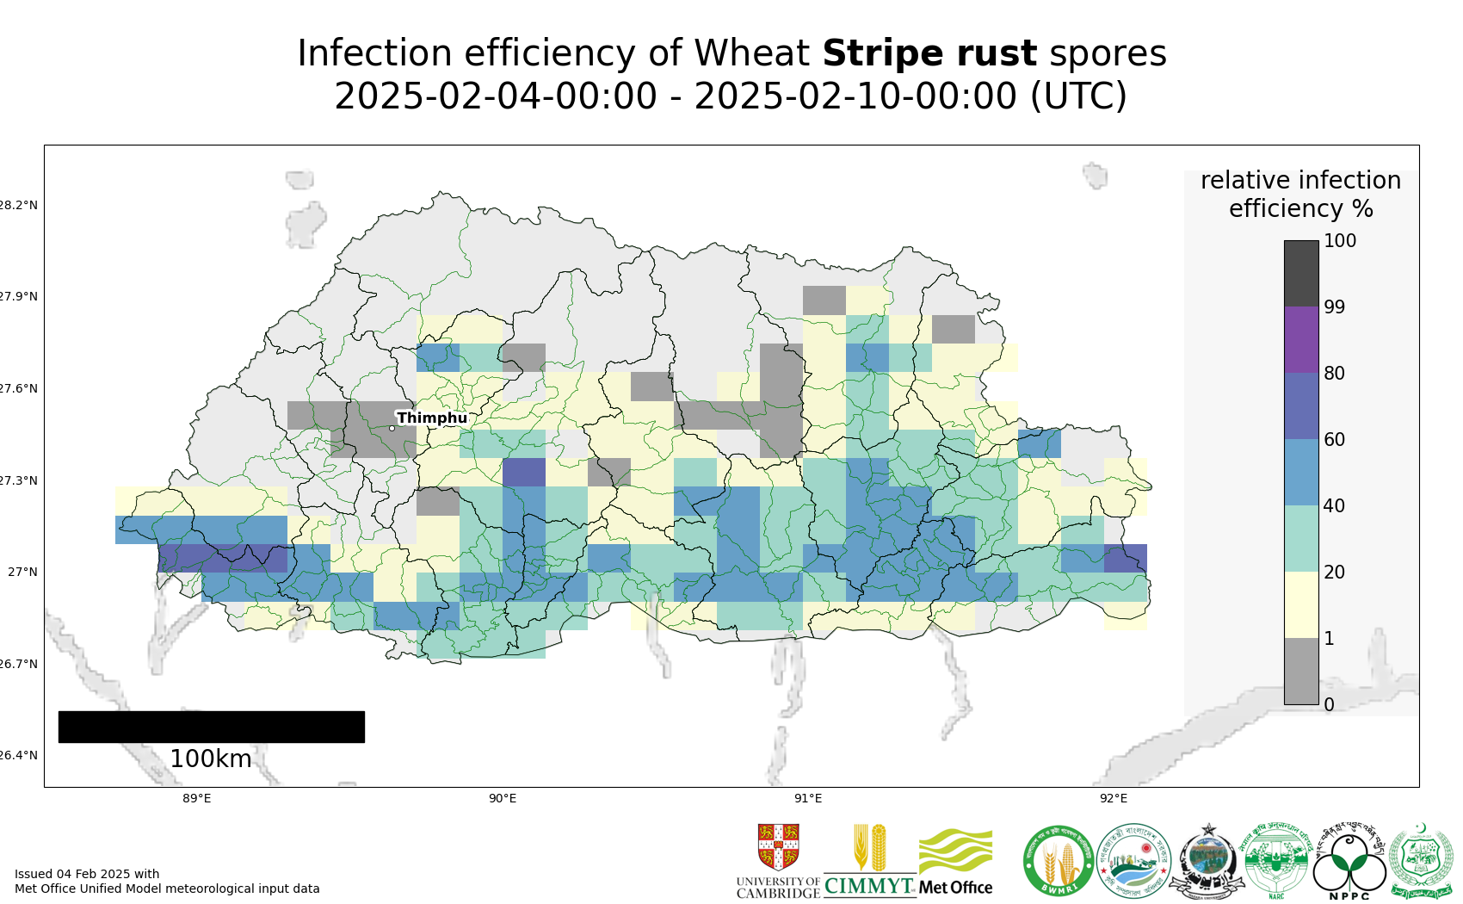
Map 4: Stripe rust suitability for infection forecast Bhutan 04 Feb - 09 Feb 2025
The 20 most impacted districts (infection efficiency) per country are presented in the table below.
admin2Name | admin1Name | RIE_stripe_rust_%
Chargharay | Samtse | 65
Dungtoe | Samtse | 65
Sipsu | Samtse | 64
Chengmari | Samtse | 59
Namgyel Chhoeling | Samtse | 56
Dorokha | Samtse | 55
Yoeseltse | Samtse | 55
Biru | Samtse | 54
Tsholingkhor | Tsirang | 52
Tsangkha | Dagana | 52
Barzhong | Tsirang | 51
Rangthangling | Tsirang | 49
Denchhukha | Samtse | 49
Ugentse | Samtse | 47
Mendrelgang | Tsirang | 46
Drugyelgang | Dagana | 46
Kikorthang | Tsirang | 45
Dungmin | Pemagatshel | 44
Chhimung | Pemagatshel | 44
Patakla | Tsirang | 44

Stem rust
Dispersal: Current forecast (04 Feb - 10 Feb) indicates no dispersal as no stem rust detected.
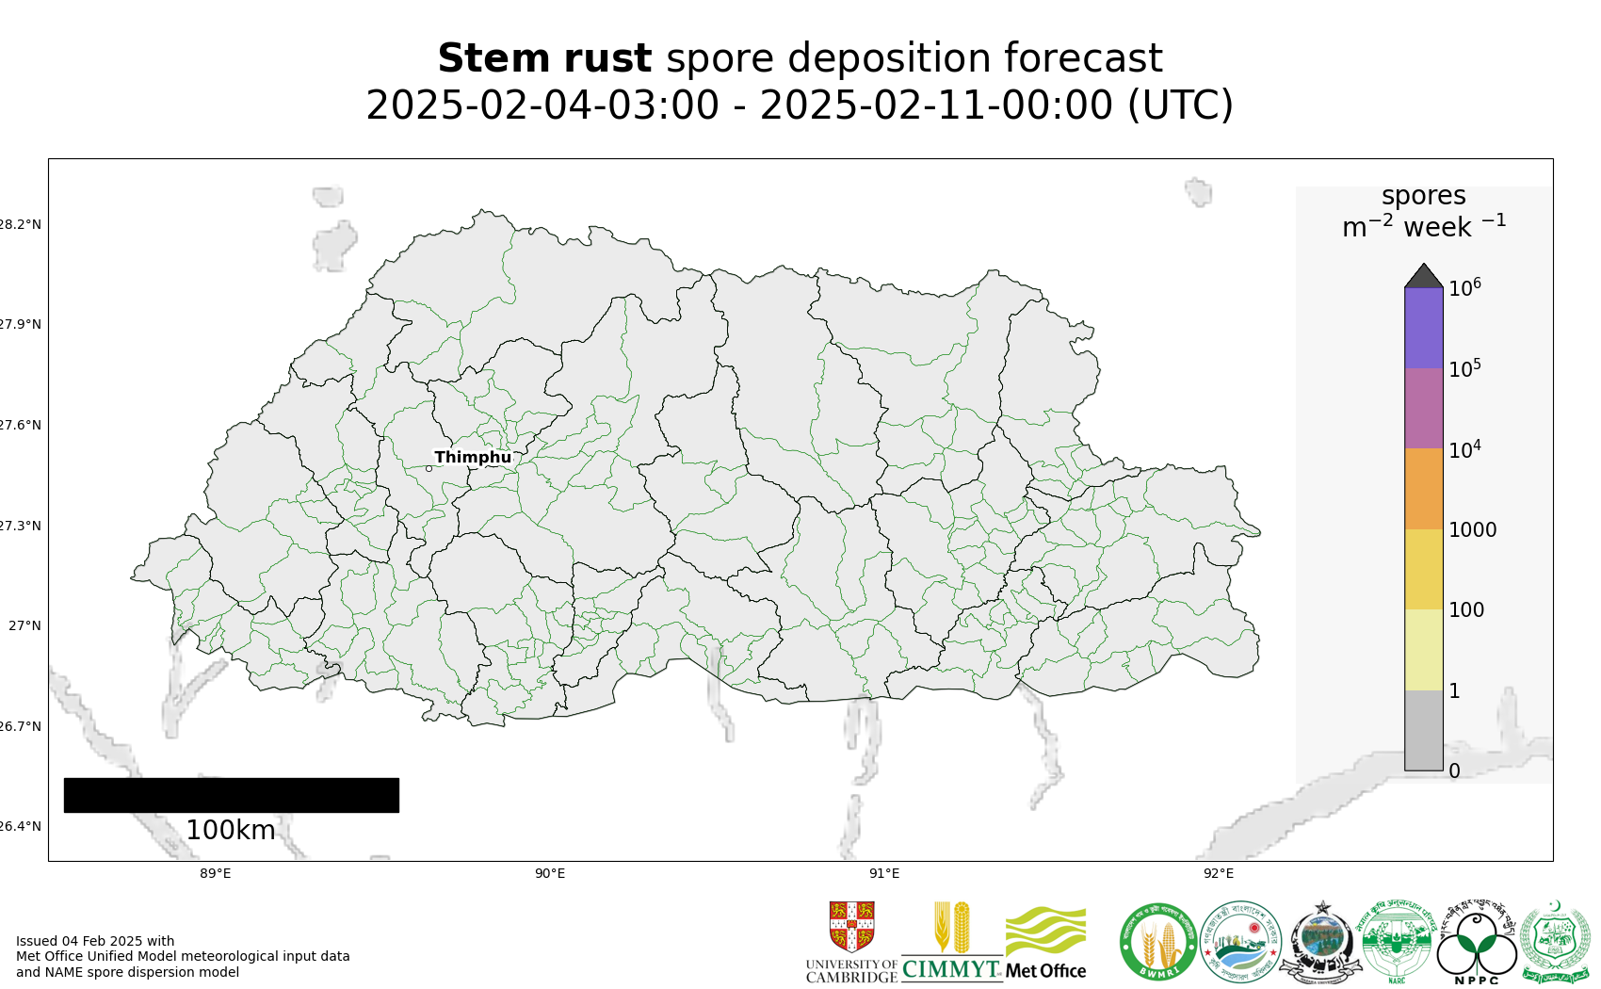
Map 5: Stem rust spore deposition forecast Bhutan 04 Feb - 10 Feb 2025
Risk of infection: Current forecast (4 – 9 Feb) indicates moderate infection efficiency across southern areas. Little or no suitability forecast in other areas.
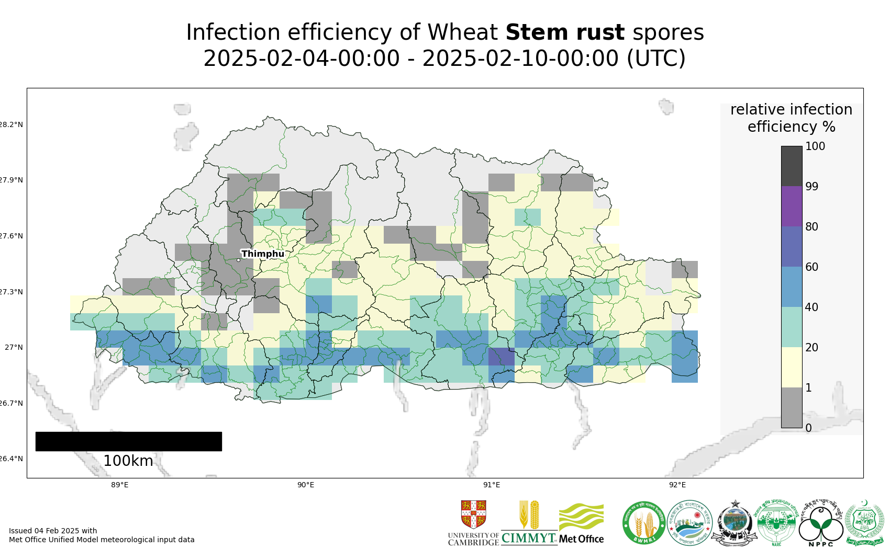
Map 6: Stem rust suitability for infection forecast Bhutan 04 Feb - 09 Feb 2025
The 20 most impacted districts (infection efficiency) per country are presented in the table below.
admin2Name | admin1Name | RIE_stem_rust_%
Ugentse | Samtse | 53
Yoeseltse | Samtse | 52
Sipsu | Samtse | 51
Yurung | Pemagatshel | 49
Barzhong | Tsirang | 49
Dorokha | Samtse | 49
Ngangla | Zhemgang | 48
Chengmari | Samtse | 48
Samtse | Samtse | 47
Tsholingkhor | Tsirang | 47
Tsangkha | Dagana | 47
Chargharay | Samtse | 46
Langchhenphu | Samdrupjongkhar | 46
Rangthangling | Tsirang | 45
Samphelling | Chhukha | 45
Dungtoe | Samtse | 45
Mendrelgang | Tsirang | 45
Gozhing | Zhemgang | 45
Zobel | Pemagatshel | 44
Denchhukha | Samtse | 44

Region-wide Forecasts
Forecasts from the National Centers for Environmental Prediction NCEP http://wxmaps.org/pix/clim
Forecasts from the National Centers for Environmental Prediction NCEP http://wxmaps.org/pix/clim
These indicate possible general conditions across South Asia, with likely decreasing prediction accuracy in the second forecast period.
Precipitation: During the period 6-14 Feb no rain is forecast across all of Bangladesh. Some light rain is forecast for Bhutan, north west India and northern Pakistan. Similar forecast for 14-22 Feb, with the possibility of heavier rain in northern Pakistan and northwest India. Overall, conditions across the region drier than normal.
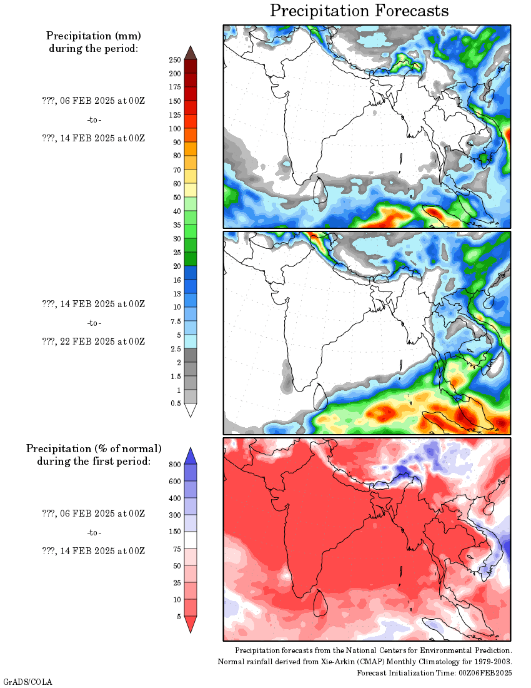
Temperature: During the period 6-14 Feb temperatures are generally slightly warmer than normal across the region, except for northern Pakistan, north west India and most of Bhutan.
